MLOPS
- Introduction to MLOPS
  - Machine Learning
Fundamentals of Machine Learning
What Is Machine Learning?
Machine Learning (ML) is a way of teaching computers to learn patterns from data instead of manually writing every rule.

Traditional Programming vs Machine Learning
Traditional Programming
In traditional programming:
- Humans write all the rules.
- Computer follows those rules exactly.
Example
if temperature > 40:
print("Hot")
else:
print("Cold")
Here:
- You explicitly define the logic.
- Computer does not learn anything.

Machine Learning
In Machine Learning:
- You give the computer examples (data).
- The computer automatically discovers patterns/rules.
Instead of writing rules manually:
Data + Correct Answers → Machine Learning Algorithm → Learned Model

Flower Species Prediction Example
Suppose we want to predict flower species.
Input Features
We collect measurements such as:
- Petal length
- Petal width
- Sepal length
- Sepal width
Output Labels
Flower species:
- Setosa
- Versicolor
- Virginica

Why Not Use If-Else Rules?
You could try:
if petal_length < 2:
species = "Setosa"
But real-world data is complicated:
- Thousands of combinations exist
- Patterns are not always obvious
- Manual rules become impossible
So instead of coding rules manually:
We let the machine learn from examples.

Training Data
We provide the algorithm with:
Petal Length | Petal Width | Sepal Length | Species
1.4 | 0.2 | 5.1 | Setosa
4.7 | 1.4 | 7.0 | Versicolor
6.0 | 2.5 | 6.3 | Virginica
This dataset contains:
- Input values (features)
- Correct answers (labels)
The algorithm studies these examples.

What Does the Algorithm Do?
The ML algorithm tries to find:
Input Features → Output Species
It searches for hidden relationships like:
- Small petals → Setosa
- Larger petals → Virginica
The algorithm learns these patterns automatically.

What Is a Model?
A model is the final learned output of machine learning.
Important
A model is:
- NOT the raw data
- NOT the algorithm itself
- It is the learned pattern/knowledge

Simple Analogy
Think of it like this:
Component | Analogy
Data | Practice questions
Algorithm | Teacher/training method
Model | Student’s learned knowledge
After learning:
- The student can answer new questions.
- Similarly, the model can predict new data.

How Training Works
During training:
Training Data → Algorithm → Model
The algorithm repeatedly studies the data and adjusts itself until it learns useful patterns.

Example of Learned Rules
The model may internally learn patterns such as:
- If petal length is very small → Setosa
- If petal length is large and width is medium → Virginica
You never explicitly programmed these rules.
The model discovered them automatically.

Using the Trained Model
Now we provide a new flower:
Petal length = 5.1
Petal width = 1.8
The model compares this with what it learned earlier.
Prediction:
Species = Versicolor
This process is called:
Inference / Prediction

Overall Machine Learning Workflow
Collect Data
↓
Train Algorithm
↓
Create Model
↓
Use Model for Predictions

Key Terms Summary
Term | Meaning
Data | Examples given to the computer
Features | Input values (petal length etc.)
Labels | Correct answers/species
Algorithm | Learning method
Training | Process of learning patterns
Model | Final learned knowledge
Prediction | Output for new data

One-Line Understanding
Machine Learning is:
Teaching computers to learn patterns from examples so they can make predictions on new data.

Most Important Concept
The model does not memorize every flower.
Instead:
- It learns general patterns
- Then applies those patterns to unseen data
That is the core idea behind machine learning.

  - Steps to Create a Model
How Data Scientists Create a Simple Machine Learning Model
Start with a Problem
Every machine learning project begins with a problem to solve.
Example
Predict flower species using:
- Petal length
- Petal width
- Sepal length
- Sepal width
The computer must learn how these measurements relate to flower species.

- Collect the Dataset
A dataset contains examples for learning.
It has two main parts:
Part | Meaning
Features (Inputs) | Flower measurements
Label (Output) | Correct flower species
Example:
Petal Length | Petal Width | Species
1.4 | 0.2 | Setosa
4.7 | 1.4 | Versicolor
6.0 | 2.5 | Virginica
The model learns from these examples.

- Split the Data
Before training, the dataset is divided into two parts.
Training Data
Usually around 80% of the data.
Purpose:
- Used for learning patterns.
Testing Data
Usually around 20% of the data.
Purpose:
- Used to check whether the model learned correctly.

Why Split the Data?
Think of a student preparing for an exam.
- Training data = practice questions
- Test data = final exam
If the student sees exam questions beforehand, the test becomes unfair.
Similarly:
- The model should be tested on unseen data.
- This helps measure real learning ability.

Choose a Machine Learning Algorithm
An algorithm is the learning method used to create the model.
For beginners, common algorithms are:
Algorithm | Use Case
Logistic Regression | Classification problems
Decision Tree | Rule-based predictions
K-Nearest Neighbors (KNN) | Similarity-based predictions
For flower prediction:
- Logistic Regression works well
- Decision Tree also works well

Train the Model
Training is the learning phase.
During training:
Training Data → Algorithm → Learned Model
The algorithm studies:
- Input measurements
- Correct species labels
Then it adjusts itself to reduce prediction mistakes.

Important Concept
You do not manually write prediction rules.
Instead:
- The algorithm automatically discovers patterns from data.
Example learned patterns:
- Small petals → Setosa
- Large petals → Virginica

Test the Model
After training, we evaluate the model using test data.
The model predicts species for unseen flowers.
Then we compare:
Predicted Output vs Actual Output
This helps measure how well the model performs.

Measure Performance
Common questions during testing:
- How many predictions are correct?
- Where is the model making mistakes?
- Can the model generalize to new data?

Improve the Model
If performance is poor, data scientists improve the model.
Common improvement methods:
Improvement | Purpose
Remove bad/noisy data | Improve data quality
Try another algorithm | Better learning method
Tune hyperparameters | Optimize settings
Add more data | Help model learn better
Even small improvements can increase accuracy significantly.

Save the Trained Model
Once the model performs well, it is saved as a file.
Common formats:
- .pkl
- .joblib
- .onnx

Why Save the Model?
Because training can take time.
Instead of training repeatedly:
- We save the learned model
- Reuse it whenever needed

Where Is the Saved Model Used?
The saved model can be deployed into:
- Web applications
- Mobile apps
- Backend APIs
- Microservices
- MLOps pipelines
This deployed model is what users interact with.

Complete Machine Learning Workflow
Collect Data
↓
Split Data
↓
Choose Algorithm
↓
Train Model
↓
Test Model
↓
Improve Model
↓
Save Model
↓
Deploy Model

Simple Real-World Analogy
Machine Learning Step | Student Analogy
Dataset | Study material
Training | Learning concepts
Testing | Writing exam
Model | Student’s knowledge
Prediction | Answering new questions

Most Important Idea
Machine learning is not about memorizing data.
It is about:
- Learning patterns
- Applying those patterns to unseen data
- Making intelligent predictions
That is the foundation of all ML systems.
  - MLOPS
What is MLOps?
MLOps stands for:
Machine Learning + Operations
It is a set of practices used to:
- Build
- Deploy
- Monitor
- Maintain
machine learning models in production efficiently and reliably.

Where Did MLOps Come From?
MLOps is inspired by: DevOps
To understand MLOps properly, you first need to understand the problem DevOps solved.

What Problems Existed Before DevOps?
In traditional software development:
Developers
- Wrote application code
Operations (Ops) Teams
- Deployed and maintained the software

Problems Before DevOps
The process was slow and difficult because:
- Deployments were manual
- Releases took a long time
- Bugs were difficult to trace
- Teams worked separately
- Failures happened frequently
There was a clear gap between:
Development Team ↔ Operations Team

What DevOps Introduced
DevOps solved these issues by introducing:
DevOps Practice | Purpose
Automation | Reduce manual work
CI/CD Pipelines | Faster software delivery
Infrastructure as Code | Manage infrastructure using code
Monitoring | Detect problems quickly
Shared Ownership | Developers and Ops work together

Result of DevOps
DevOps made software systems:
- Faster to release
- More reliable
- Easier to maintain
- Easier to improve continuously

The Same Problem Happened in Machine Learning
Machine Learning teams faced very similar challenges.

Typical ML Workflow Before MLOps
Data Scientists
- Built models in Jupyter notebooks
- Trained models locally
- Achieved good accuracy
But then problems started.

Production Problems in ML
Production teams struggled because:
- Models worked only on local machines
- Deployment was difficult
- No standard workflow existed
- Ownership after deployment was unclear
- Models silently became worse over time
There was a gap between:
Model Development ↔ Model Operations

Why Models Fail in Production
Unlike normal software, ML systems depend on:
- Data quality
- Data distribution
- Continuous retraining
- Model monitoring
Over time:
- Real-world data changes
- Model accuracy decreases
This is called:
Model Drift
Without monitoring, failures may go unnoticed.

What MLOps Solves
MLOps was created to solve these ML production challenges.
It applies DevOps principles to Machine Learning systems.

Simple Definition of MLOps
MLOps is the practice of automating and managing the complete machine learning lifecycle.

ML Lifecycle Managed by MLOps
Data Collection
↓
Model Training
↓
Testing & Validation
↓
Deployment
↓
Monitoring
↓
Retraining & Improvement
MLOps manages this entire pipeline efficiently.

DevOps vs MLOps
DevOps Concept | MLOps Equivalent
Source code versioning | Data + model versioning
CI pipelines | Model training pipelines
CD pipelines | Automated model deployment
Monitoring services | Model performance monitoring
Rollbacks | Model version rollback
Automation | End-to-end ML automation

Important Difference Between Software and ML Systems
Traditional Software
Behavior changes only when developers change code.
ML Systems
Behavior can change even if code stays the same because:
- Data changes
- User behavior changes
- Environment changes
That makes ML systems harder to maintain.

Core Goals of MLOps
MLOps aims to make ML systems:
Goal | Meaning
Reproducible | Same results every time
Automated | Minimal manual work
Scalable | Handle large workloads
Monitorable | Detect failures/drift
Reliable | Stable in production
Maintainable | Easy to update

Real-World Example
Imagine a movie recommendation system.
Without MLOps:
- Recommendations slowly become bad
- Nobody notices quickly
- Updating models is manual
With MLOps:
- Performance is monitored continuously
- New models deploy automatically
- Failures can be rolled back safely

Simple Analogy
Traditional ML | MLOps
Building a model | Running a production ML factory
One-time experiment | Continuous lifecycle management
Notebook-focused | Production-focused

Most Important Idea
Machine Learning is not just about training a model.
The real challenge is:
Running ML systems reliably in production
MLOps exists to solve that challenge.

Realtime Examples:
Netflix Example
DevOps at Netflix
DevOps manages the Netflix platform itself:
- Deploying web/mobile applications
- Managing cloud infrastructure
- Running CI/CD pipelines
- Monitoring servers and APIs
Goal
Keep Netflix software fast, scalable, and reliable.

MLOps at Netflix
MLOps manages Netflix ML systems:
- Recommendation engine
- Personalized homepage
- Search ranking
- Content prediction
Goal
Keep ML models accurate and continuously improving.

PayPal Example
DevOps at PayPal
DevOps manages:
- Payment systems
- APIs
- Backend infrastructure
- Security and deployments
Goal
Ensure secure and reliable payment processing.

MLOps at PayPal
MLOps manages:
- Fraud detection models
- Risk analysis systems
- Real-time transaction predictions
Goal
Detect fraud accurately and retrain models as fraud patterns change.

Simple Difference
DevOps | MLOps
Manages software systems | Manages ML systems
Focuses on applications/infrastructure | Focuses on models/data pipelines
Ensures reliable deployments | Ensures reliable predictions

One-Line Understanding
DevOps runs the platform.
MLOps runs the intelligence inside the platform.

  - Machine Learning Lifecycle
Machine Learning Lifecycle
The Machine Learning Lifecycle is the complete process of:
Building → Deploying → Monitoring → Improving
a machine learning model.
It starts with a business problem and continues even after deployment.

- Problem Definition
Before building a model, first understand:
- What problem are we solving?
- What type of ML problem is it?
Examples:
- Classification → Spam or Not Spam
- Regression → House Price Prediction
- Clustering → Customer Segmentation

Define Success Criteria
Decide how success will be measured.
Examples:
- Accuracy
- Prediction speed (latency)
- Cost
- Business impact

- Data Collection
Machine learning needs data to learn.
Data can come from:
- Databases
- APIs
- User activity
- Logs
- Sensors
- CSV files

Important Goal
The data should represent real-world situations properly.
Better data → Better model.

- Data Cleaning & Preparation
Raw data is usually messy.
This step improves data quality.

Common Tasks
Handle Missing Values
Example:
- Empty age column
- Missing addresses
Remove Duplicates
Same record appearing multiple times.
Fix Incorrect Data
Example:
- Negative salary values
- Wrong formats

Split the Dataset
Usually divided into:
Dataset | Purpose
Training Set | Learn patterns
Validation Set | Tune model
Test Set | Final evaluation

Important Note
This is often the most time-consuming stage in ML projects.

- Feature Engineering
Features are the inputs given to the model.
Feature engineering transforms raw data into useful information.

Examples
Raw Data | Engineered Feature
Timestamp | Day, month, weekday
Text | Word embeddings
Category | One-hot encoding
Numbers | Scaling/normalization

Key Idea
Better features → Better model performance

- Model Selection
Choose the right algorithm for the problem.
Examples:
Algorithm | Use Case
Linear Regression | Predict numbers
Decision Tree | Classification
Random Forest | Complex patterns
Gradient Boosting | High accuracy tasks
Neural Networks | Deep learning problems

- Model Training
Training is the learning process.
The model studies:
- Input data
- Correct outputs
Then learns patterns automatically.

Goal During Training
Reduce prediction mistakes (error).

- Model Evaluation
After training, test the model on unseen data.
This checks:
- How accurate the model is
- Whether it generalizes well

Common Evaluation Metrics
Metric | Meaning
Accuracy | Correct predictions
F1-Score | Balance between precision & recall
RMSE | Regression error
ROC-AUC | Classification quality

- Hyperparameter Tuning
Hyperparameters are settings that control model behavior.
Examples:
- Learning rate
- Tree depth
- Batch size

Goal
Find the best settings to improve performance.

Common Tuning Techniques
- Grid Search
- Random Search
- Bayesian Optimization

- Model Deployment
Once the model performs well:
- Move it to production
- Make it available to users/applications

Deployment Options
Deployment Type | Example
REST API | Web applications
Batch Jobs | Daily predictions
Edge Devices | Mobile/IoT
Cloud Platforms | AWS SageMaker, Vertex AI

- Monitoring & Logging
After deployment, continuously monitor the model.

What Is Monitored?
Monitoring Area | Purpose
Accuracy | Detect performance drop
Latency | Response speed
Errors | Failures/crashes
Data Drift | Detect changing data patterns

Why Monitoring Matters
Real-world data changes over time.
This can reduce model quality silently.

- Model Maintenance
Machine learning models are not “build once forever.”
They require continuous updates.

Common Maintenance Tasks
- Retrain with new data
- Update pipelines
- Improve features
- Fix bugs
- Version control models/data/code

Complete ML Lifecycle
Problem Definition
↓
Data Collection
↓
Data Cleaning & Preparation
↓
Feature Engineering
↓
Model Selection
↓
Model Training
↓
Model Evaluation
↓
Hyperparameter Tuning
↓
Model Deployment
↓
Monitoring & Logging
↓
Model Maintenance

Simple Real-World Analogy
ML Lifecycle Step | Student Analogy
Data Collection | Gathering study material
Training | Learning concepts
Evaluation | Writing exams
Deployment | Working in real job
Monitoring | Performance reviews
Maintenance | Continuous learning

Most Important Understanding
Machine Learning is not only about training a model.
The real challenge is:
Managing the entire lifecycle reliably in production.
That complete lifecycle is what MLOps focuses on.

  - Data Scientist vs ML Engineer vs MLOps Engineer
In a real Machine Learning team, these three roles work together to build and run ML systems.
Each role has a different responsibility.

Data Scientist
The “Brain Behind the Model”
A Data Scientist mainly focuses on:
Understanding data and building ML models

What a Data Scientist Does
Understand Business Problems
Example:
- Predict customer churn
- Detect fraud
- Recommend movies
Work with Data
- Explore datasets
- Clean data
- Prepare features
Build ML Models
- Try different algorithms
- Train models
- Evaluate accuracy
Share Insights
- Explain results to stakeholders
- Create reports and visualizations

Think of Them As
Researcher + Statistician + Problem Solver
They mostly work in:
- Jupyter notebooks
- Experiment environments

Usually NOT Responsible For
- Deployment
- Cloud infrastructure
- CI/CD pipelines
- Monitoring systems
- Scalability

ML Engineer
The “Builder Who Converts Model Into a Product”
An ML Engineer focuses on:
Turning ML models into production-ready applications

What an ML Engineer Does
Take the Trained Model
Uses the model created by the Data Scientist.
Build Production Systems
- Create APIs
- Integrate models into applications
- Connect backend services
Optimize Performance
Improve:
- Latency
- Throughput
- Memory usage
Ensure Reliability
Make sure predictions work efficiently in production.

Think of Them As
Software Engineer + Machine Learning Specialist

Usually NOT Responsible For
- Full ML lifecycle automation
- Large-scale monitoring
- Model governance
- Training pipeline infrastructure

MLOps Engineer
The “DevOps Engineer for Machine Learning”
An MLOps Engineer focuses on:
Automating and managing the ML lifecycle

What an MLOps Engineer Does
Build ML Pipelines
Automate:
- Data ingestion
- Feature engineering
- Model training
Manage ML Infrastructure
Work with:
- Kubernetes
- GPUs
- Cloud platforms
- Scaling systems
Automate Deployment
Set up:
- CI/CD for ML
- Model deployment workflows
- Model registry systems
Monitor Models
Track:
- Accuracy
- Drift
- Latency
- Failures
Enable Teams
Help Data Scientists and ML Engineers deploy models faster and safely.

Think of Them As
DevOps + Cloud + ML Automation Engineer

Usually NOT Responsible For
- Deep data analysis
- Researching new ML algorithms
- Creating initial ML models

Simple Workflow of All Three Roles
Data Scientist
↓
Creates ML Model
↓
ML Engineer
↓
Builds Production Application
↓
MLOps Engineer
↓
Automates, Deploys, Monitors & Scales

Real-World Analogy
Role | Analogy
Data Scientist | Chef creating the recipe
ML Engineer | Cook preparing dishes at scale
MLOps Engineer | Restaurant operations manager ensuring everything runs smoothly

Quick Comparison Table
Role | Main Focus
Data Scientist | Build and improve models
ML Engineer | Productionize ML models
MLOps Engineer | Automate and manage ML systems

One-Line Understanding
Data Scientist → Creates the model

ML Engineer → Turns the model into a product

MLOps Engineer → Builds the system that deploys, scales, and monitors the model

ML Lifecycle Roles Mind Map
ML Lifecycle Stage | Data Scientist (DS) | ML Engineer (MLE) | MLOps Engineer
Problem Definition | ✅ Primary Role | ❌ | ❌
Data Collection | ✅ Primary Role | ❌ | ✅ Pipeline Automation Support
Data Cleaning & Preparation | ✅ Primary Role | ❌ | ✅ Data Pipeline Support
Feature Engineering | ✅ Primary Role | ❌ | ✅ Feature Pipeline Automation
Model Selection | ✅ Primary Role | ❌ | ❌
Model Training | ✅ Primary Role | ❌ | ✅ Primary Role (Training Pipeline Automation)
Model Evaluation | ✅ Primary Role | ❌ | ✅ Evaluation Pipeline Support
Hyperparameter Tuning | ✅ Primary Role | ❌ | ✅ Primary Role (Automated Tuning Pipelines)
Model Deployment | ❌ | ✅ Primary Role | ✅ Primary Role (CI/CD & Deployment Automation)
Monitoring & Logging | ❌ | ❌ | ✅ Primary Role
Model Maintenance | ❌ | ❌ | ✅ Primary Role (Retraining & Lifecycle Management)

- ROLE OF MLOPS
  - Git Repo Link for MLOPS Example
Repo link - https://github.com/iam-veeramalla/hello-world-mlops

  - Data Scientist Without MLOPS
Role of a Data Scientist
A Data Scientist focuses on:
Understanding data, finding patterns, and building ML models
Their main goal is to create a model that can solve a business problem.
They mainly work on:
- Data
- Analysis
- Model building
- Predictions
They usually do not focus on:
- Deployment
- CI/CD
- Cloud infrastructure
- Monitoring systems

Understand the Business Problem
The first step is understanding:
- What problem are we solving?
- Why are we solving it?
- What does success look like?

Example Problems
- Predict customer churn
- Detect spam emails
- Recommend products
- Classify customer support tickets

Important Idea
At this stage:
- No coding yet
- No model yet
- Only problem understanding

Collect and Understand Data
Once the problem is clear, the Data Scientist works with data.

Common Data Sources
- CSV files
- Databases
- APIs
- Logs
- Excel sheets

Main Activities
Understand the Dataset
- Columns
- Data types
- Target variable
Check Data Quality
- Missing values
- Incorrect entries
- Duplicate records
- Noisy data

Goal of This Stage
Understand the data before building models

Clean and Prepare the Data
Real-world data is messy.
Data Scientists clean the data to make it usable for ML.

Common Cleaning Tasks
Task | Purpose
Remove duplicates | Avoid repeated data
Handle missing values | Improve quality
Fix incorrect data | Correct errors
Convert text to numbers | ML models need numerical input
Scale/normalize values | Improve model learning

Important Understanding
Data cleaning usually takes more time than model building

Exploratory Data Analysis (EDA)
EDA means:
Understanding patterns and relationships in data

Activities During EDA
- Plot graphs
- Check correlations
- Find outliers
- Compare distributions

Goal of EDA
Understand:
- Which features are useful
- What affects predictions
- Which model may work well

Build a Simple Model
Now the actual ML phase starts.
The Data Scientist:
- Chooses an algorithm
- Trains the model
- Tests initial performance

Beginner-Friendly Algorithms
Algorithm | Use Case
Logistic Regression | Classification
Decision Tree | Rule-based learning
Naive Bayes | Probability-based classification

Important Idea
Initially:
- Simplicity is preferred
- Clarity matters more than complexity

Evaluate the Model
After training, the model is tested.

Common Evaluation Metrics
Metric | Meaning
Accuracy | Correct predictions
Precision | Correct positive predictions
Recall | Ability to find positives
Confusion Matrix | Detailed prediction analysis

Questions Asked During Evaluation
- Is the model better than random guessing?
- Is it making obvious mistakes?
- Is it usable for a demo or proof of concept?

Important Understanding
At this stage:
- Focus is only on model quality
- Not production deployment

Save the Model
Once satisfied with performance:
The Data Scientist saves the trained model.

Common Model Formats
- .pkl
- .joblib
- .onnx

What Happens After Saving?
The model:
- Exists as a file
- Can be shared with the team
But:
- It is NOT deployed yet
- It is NOT automated yet
That is usually where the Data Scientist’s core work ends.

Complete Workflow of a Data Scientist
Understand Business Problem
↓
Collect & Understand Data
↓
Clean & Prepare Data
↓
Perform EDA
↓
Build Model
↓
Evaluate Model
↓
Save Model

Simple Real-World Analogy
Data Scientist Work | Analogy
Understand problem | Doctor diagnosing patient
Analyze data | Running medical tests
Build model | Creating treatment plan
Evaluate model | Checking treatment effectiveness

Most Important Understanding
A Data Scientist’s main responsibility is creating a useful and accurate ML model from data.
They focus on:
- Data
- Insights
- Predictions
Not on:
- Deployment
- Automation
- Infrastructure

  - How MLOps Engineers Help Data Scientists
How MLOps Engineers Help Data Scientists
MLOps Engineers help Data Scientists by:
Automating, standardizing, and managing the model training process
They make ML workflows:
- Reliable
- Repeatable
- Scalable

Problem Before MLOps
Traditionally, Data Scientists trained models by:
- Running scripts manually
- Clicking “Run” in notebooks
- Training only on local machines

Problems With This Approach
Problem | Issue
Manual training | Time-consuming
Local machine dependency | Hard to reproduce
Different environments | Inconsistent results
No automation | Difficult to scale
Hidden errors | Hard to debug

What MLOps Engineers Introduce
MLOps Engineers solve these problems using:
CI (Continuous Integration) + Automation
Tools commonly used:
- GitHub Actions
- Jenkins
- GitLab CI
- Cloud pipelines

Training Becomes Automatic
Instead of humans manually starting training:
MLOps Engineers define rules like:
- Train when new code is pushed
- Train when data changes
- Train after pull request merge

Result
Training becomes:
Benefit | Meaning
Predictable | Same process every time
Consistent | Standard workflow
Automated | No manual triggering
Scalable | Works for large teams

Standardized Training Environment
Local systems differ:
- Python versions
- Library versions
- Operating systems
This creates inconsistencies.

What MLOps Engineers Do
They ensure every training run uses:
- Same Python version
- Same dependencies
- Same environment setup
Usually through:
- Docker
- Virtual environments
- CI runners

Important Benefit
"If it works locally, it should also work in CI."
This improves reproducibility.

Clean Training Every Time
Each CI pipeline starts from a fresh environment.
No:
- Old files
- Cached outputs
- Manual changes

Why This Matters
It ensures:
Benefit | Meaning
Reproducibility | Same results repeatedly
Reliability | Trustworthy training
Consistency | No hidden dependencies

Automatic Model Generation
When CI runs:
Code + Data → Automatic Training → New Model
The latest model is generated automatically.

Benefits for Data Scientists
They no longer need to:
- Train manually every time
- Share model files through email/chat
- Depend on personal laptops

Experiment Tracking
Every training run is connected to:
- Git commit
- Timestamp
- Code version
- Dataset version

Why Tracking Matters
It helps answer questions like:
- Which code created this model?
- Why did accuracy change?
- What caused performance improvements?

Early Failure Detection
If something breaks:
- Dependency issue
- Bad data format
- Training failure
CI immediately reports the error.

Benefit to Data Scientists
They can:
- Detect problems early
- Fix issues faster
- Prevent broken models from reaching production

Simple Workflow
Data Scientist Pushes Code
↓
CI Pipeline Starts Automatically
↓
Fresh Environment Created
↓
Model Training Runs
↓
Model Generated & Tracked
↓
Errors Detected Early

Real-World Analogy
Without MLOps | With MLOps
Cooking manually every time | Automated kitchen system
Different recipe each run | Standardized recipe
Hard to reproduce results | Consistent output every time

Most Important Understanding
MLOps Engineers help Data Scientists move from manual experimentation to automated and reproducible ML workflows.
They make ML training:
- Automated
- Reliable
- Scalable
- Production-ready

  - Role of an ML Engineer in a Project
Once a Data Scientist creates a trained model, the next challenge is:
How can real users and applications use this model?
This is where the ML Engineer comes in.

Main Responsibility of an ML Engineer
An ML Engineer focuses on:
Turning a trained ML model into a production-ready application
They bridge the gap between:
- Machine Learning
- Software Engineering

Turn the Model into an API
A trained model is usually just a file like:
- .pkl
- .joblib
- .onnx
By itself, it cannot serve users directly.

What the ML Engineer Does
The ML Engineer wraps the model inside an API.

Typical Workflow
Load the Trained Model
The saved model is loaded into memory.
Accept User Input
Applications send data (usually JSON format).
Example:
{
"petal_length": 5.1,
"petal_width": 1.8
}
Run Prediction
The model processes the input and predicts the result.
Return Response
Prediction is sent back to the application.
Example:
{
"species": "Versicolor"
}

Result
Now the model becomes usable by:
- Frontend applications
- Backend services
- Mobile apps
- Websites

Important Understanding
The model changes from an experiment into a usable product.

Handle Input and Output Safely
In production, users may send:
- Wrong data
- Missing fields
- Invalid formats
Without proper handling:
- APIs may crash
- Predictions may become incorrect

What the ML Engineer Ensures
Input Validation
Check:
- Required fields exist
- Correct data types are provided
Error Handling
Prevent system crashes when bad input arrives.
Safe Responses
Return proper error messages instead of failures.

Example
If a user sends:
{
"petal_length": "abc"
}
The API should safely return:
Invalid input: petal_length must be numeric
instead of crashing.

Why This Matters
It prevents:
- Production incidents
- Bad user experience
- Incorrect predictions

Make the Model Fast and Efficient
A model working in a notebook may not work efficiently in production.
Problems may include:
- Slow predictions
- High memory usage
- Reloading model repeatedly

What ML Engineers Optimize
Faster Predictions
Reduce response time (latency).
Efficient Memory Usage
Avoid unnecessary resource consumption.
Load Model Once
Instead of loading the model for every request:
- Keep it loaded in memory
This improves speed significantly.

Goal of Optimization
Serve predictions quickly and reliably for real users

Simple Production Workflow
User/Application
↓
API Request
↓
ML Engineer’s Service
↓
Load Model
↓
Run Prediction
↓
Return Response

Real-World Analogy
ML Engineer Work | Analogy
Model from Data Scientist | Car engine
API creation | Building the complete car
Optimization | Making the car fast and efficient
Input validation | Safety systems in the car

Relationship Between Roles
Data Scientist
↓
Builds the ML Model
↓
ML Engineer
↓
Turns the Model into a Production Application

Most Important Understanding
An ML Engineer makes ML models usable, reliable, and efficient in real-world applications.
They focus on:
- APIs
- Production systems
- Performance
- Reliability
Not on:
- Deep research
- Heavy data analysis
- Model experimentation

  - How MLOps Engineers Help ML Engineers
How MLOps Engineers Help ML Engineers
MLOps Engineers help ML Engineers by:
Managing infrastructure, automation, deployment, and production reliability
This allows ML Engineers to focus mainly on:
- Model APIs
- Prediction logic
- Application integration

Main Goal of MLOps Engineers
Make ML services scalable, reliable, and production-ready

Creating Dockerfiles & Standardizing Runtime
Different systems may have:
- Different Python versions
- Different libraries
- Different OS configurations
This can cause:
"It works on my machine but fails in production"

What MLOps Engineers Do
They create Dockerfiles that define:
- Python version
- Required dependencies
- OS environment
- API startup commands

Why This Helps ML Engineers
The API behaves consistently on:
- Local laptops
- Virtual machines
- Cloud servers
- Kubernetes clusters

Containerizing the Model & API
Once the ML Engineer builds the API:
MLOps Engineers package everything into containers.

What They Package
Model + API + Dependencies + Runtime Environment
using Docker containers.

Benefits of Containerization
Benefit | Meaning
Portability | Run anywhere
Consistency | Same behavior everywhere
Isolation | Avoid dependency conflicts
Easier deployment | Simple production rollout

Deploying to VMs or Kubernetes
After containerization, the service must be deployed.

What MLOps Engineers Handle
Simple Deployments
Run containers on:
- Virtual Machines (VMs)
Scalable Deployments
Deploy on:
- Kubernetes clusters

Responsibilities During Deployment
- Infrastructure setup
- Environment configuration
- Runtime management
- Scaling systems

Why This Helps ML Engineers
ML Engineers do not need to manage:
- Servers
- Clusters
- Cloud infrastructure
- Deployment environments

Load Balancing & Networking
Real-world applications receive traffic from many users.

What MLOps Engineers Configure
Load Balancers
Distribute requests across multiple API instances.
Networking
Enable secure communication between services.
Traffic Distribution
Prevent one server from becoming overloaded.

Result
The ML API can handle many users reliably and efficiently.

Making the Service Production-Ready
A working API is not enough for production.
MLOps Engineers add operational reliability.

Production Features Added
Feature | Purpose
Health Checks | Verify service is running
Logging | Track issues/errors
Monitoring | Observe performance
Rollbacks | Recover safely from failures

Why This Matters
It ensures:
- Stable deployments
- Faster debugging
- Safer updates
- Better uptime

Relationship Between ML Engineer & MLOps Engineer
ML Engineer
↓
Builds Model API
↓
MLOps Engineer
↓
Containerizes, Deploys, Scales & Monitors the Service

Simple Real-World Analogy
Role | Analogy
ML Engineer | Builds the car engine
MLOps Engineer | Builds the roads, traffic systems, maintenance & safety infrastructure

Quick Responsibility Split
ML Engineer | MLOps Engineer
Builds prediction API | Deploys and manages infrastructure
Handles model logic | Handles automation & scaling
Optimizes prediction code | Optimizes deployment reliability
Focuses on application layer | Focuses on operational layer

One-Line Understanding
ML Engineers build ML services.
MLOps Engineers make those services scalable, reliable, and production-ready.

- Data Versioning and Data Version Control (DVC)
  - Data Versioning – Why Git Isn’t Enough?
Git is excellent for:
Versioning source code
But Machine Learning projects also need to version:
- Datasets
- Features
- Model artifacts
- Experiments
This is where Git alone becomes insufficient.

Why Versioning Matters in ML
In ML projects, data changes continuously.
Examples:
- New customer records added
- Images updated
- Features modified
- Data cleaning rules changed
Even small data changes can affect:
- Model accuracy
- Predictions
- Training results
So teams must track:
- Which data was used
- What changed
- Which model came from which dataset

Problem: Git Is Not Built for Large Files
Git works best for:
- Small text files
- Source code

Why This Becomes a Problem
ML datasets are often:
- Gigabytes (GBs)
- Terabytes (TBs)
Git stores every version inside the repository.
Result:
Problem | Effect
Huge repository size | Slow cloning/pulling
Large history | Poor performance
Heavy storage usage | Expensive and difficult to manage

Git Cannot Handle Binary Data Properly
Most ML datasets are binary files:
- Images
- Videos
- Audio
- Parquet files
- Large CSVs

Why This Is Difficult for Git
Git cannot efficiently compare binary files.
For code:
Git stores only small text differences (diffs)
But for binary files:
Git often stores the entire file again
Even a tiny change can create huge storage overhead.

No Dataset Lineage Tracking
In ML, teams need to know:
- Where did the data come from?
- What preprocessing was applied?
- Which dataset version trained which model?
This is called:
Data Lineage

Git Cannot Track
- Data pipelines
- Feature transformations
- Dataset relationships
- Data quality workflows

No Dataset Metadata Support
ML datasets require metadata such as:
Metadata Type | Example
Schema | Column structure
Statistics | Missing values, min/max
Splits | Train/validation/test
Provenance | Data source history
Git does not provide this information.

Collaboration Becomes Difficult
In teams, multiple people work on datasets simultaneously.
Problems with Git:
- Pulling multi-GB datasets is slow
- Merge conflicts on binary files are difficult/impossible
- CI/CD pipelines become slow

Storage Costs Increase
As dataset versions grow:
Repository size grows rapidly
This increases:
- Storage costs
- Bandwidth costs
- Infrastructure complexity

ML Needs Experiment-Level Tracking
ML teams frequently ask questions like:
- Which dataset trained model v3?
- Why did accuracy drop?
- What changed between dataset versions?

Git Cannot Connect
ML Component | Git Limitation
Dataset versions | Limited support
Experiment tracking | Not supported
Model artifacts | Hard to manage
Pipeline tracking | Not supported

Tools Built for ML Data Versioning
Specialized tools solve these problems.
Examples:
Tool | Purpose
DVC | Data & pipeline versioning
LakeFS | Data lake version control
MLflow | Experiment tracking
Delta Lake | Data versioning & reliability

What These Tools Provide
Feature | Benefit
Efficient storage | Avoid duplicate copies
Deduplication | Save storage space
Data lineage | Track dataset history
Metadata tracking | Better reproducibility
Experiment tracking | Connect data + model + code

Simple Comparison
Git | Data Versioning Tools
Designed for code | Designed for ML data
Handles small text files | Handles massive datasets
Tracks code changes | Tracks data + experiments
Weak binary support | Optimized for large files
No ML metadata | Full ML lineage & tracking

Simple Real-World Analogy
Scenario | Analogy
Using Git for datasets | Trying to store movies inside a notebook
Using DVC/LakeFS | Using a proper warehouse system

Most Important Understanding
Git is great for versioning code.
ML systems need specialized tools to version large datasets, track lineage, and manage experiments reliably.
That is why:
Git alone is not enough for Machine Learning workflows.
  - Introduction DVC (Data Version Control)
What is DVC?
DVC stands for:
Data Version Control
Think of DVC as:
Git for Machine Learning data
It helps manage:
- Large datasets
- Model files
- ML pipelines
without storing them directly inside Git.

Why DVC Is Needed
Git works well for:
- Source code
- Small text files
But ML projects contain:
- Large CSV files
- Images
- Videos
- Model files
Git struggles with these large files.

Problems Without DVC
If datasets are stored directly in Git:
Problem | Effect
Large repository size | Slow Git operations
Heavy storage usage | Expensive repositories
Difficult collaboration | Slow cloning/pulling
Version tracking becomes messy | Hard reproducibility

What DVC Solves
DVC helps by:
Feature | Benefit
Dataset versioning | Track data changes
External storage support | Keep Git lightweight
Reproducibility | Recreate experiments easily
Collaboration | Share datasets efficiently

Simple Idea Behind DVC
With DVC:
Git stores metadata
DVC stores actual data externally

Where Data Is Stored
Actual datasets can be stored in:
- AWS S3
- Google Cloud Storage (GCS)
- Azure Blob Storage
- Local storage

Wine Prediction Example
Suppose you are building a:
Wine Quality Prediction Model
Your project contains:
File | Purpose
wine_data_sample.csv | Dataset
train.py | Training script
Git repository | Version control

Problem Without DVC
If the CSV is committed directly to Git:
Git repo becomes slow and heavy
because datasets keep growing over time.

How DVC Helps
Instead of storing the dataset in Git:
DVC creates a small metadata file:
wine_data_sample.csv.dvc

Important Understanding
Git Stores:
- .dvc metadata file
DVC Stores:
- Actual dataset in cloud/external storage
This keeps the Git repository clean and lightweight.

Simple DVC Workflow
Step 1 — Add Dataset to DVC
dvc add wine_data_sample.csv
DVC starts tracking the dataset.

Step 2 — Commit Metadata to Git
git add wine_data_sample.csv.dvc
git commit -m "Track dataset with DVC"
Only the metadata file goes into Git.

Step 3 — Configure Remote Storage
Example using AWS S3:
dvc remote add -d myremote s3://mybucket/dvcstore
This tells DVC where to store real data.

Step 4 — Push Data to Remote Storage
dvc push
Now the actual dataset is uploaded to S3.

How Team Members Get the Dataset
Another developer clones the Git repo and runs:
dvc pull
DVC downloads:
- The exact dataset version
- From remote storage

Key Benefit
Everyone gets:
The same dataset version every time
This improves:
- Collaboration
- Reproducibility
- Experiment consistency

Git vs DVC
Git | DVC
Tracks code | Tracks datasets/models
Stores small files | Handles large files
Poor for ML data | Designed for ML workflows
No dataset lineage | Supports reproducibility

Simple Real-World Analogy
Scenario | Analogy
Git | Notebook storing recipes
DVC | Warehouse storing huge ingredients/data
Git stores instructions.
DVC stores the heavy materials.

Complete Workflow
Dataset
↓
DVC Tracks Dataset
↓
Git Stores Metadata (.dvc file)
↓
Actual Data Stored in S3/GCS/Azure
↓
Team Members Run dvc pull
↓
Same Dataset Retrieved Everywhere

Most Important Understanding
DVC helps Machine Learning teams version large datasets efficiently without storing the actual data inside Git.
It enables:
- Reproducibility
- Collaboration
- Clean repositories
- Efficient ML workflows

  - DVC Demo – Step-by-Step Structured Summary
Abhishek V repo - https://github.com/iam-veeramalla/Wine-Prediction-Model/blob/main/data/.gitignore
My Repo - https://github.com/parameshnaathi/ML-Ops
Goal of the Demo
Learn how to:
- Use DVC for data versioning
- Store datasets in AWS S3
- Use Git + DVC together
- Track multiple dataset versions
- Collaborate with team members using consistent dataset versions

Project Used
Wine Quality Prediction Project
Dataset:
wine_sample.csv
Files:
- Dataset → wine_sample.csv
- Training code → train.py
- Git repository
- DVC for dataset tracking

Important Understanding Before Starting
Git vs DVC Responsibilities
Tool | Stores What
Git | Code + .dvc metadata files
DVC | Large datasets/models
S3 Bucket | Actual dataset storage

Step 1 — Create Project Directory
mkdir wine-prediction-demo
cd wine-prediction-demo
Create data folder:
mkdir data
Add dataset:
vim data/wine_sample.csv
Add this script: Press Esc and press I and paste this content
fixed_acidity,volatile_acidity,citric_acid,residual_sugar,chlorides,alcohol,quality
7.4,0.70,0.00,1.9,0.076,9.4,5
7.8,0.88,0.00,2.6,0.098,9.8,5
7.8,0.76,0.04,2.3,0.092,9.8,5
11.2,0.28,0.56,1.9,0.075,10.5,6
7.4,0.70,0.00,1.9,0.076,9.4,5
7.9,0.60,0.06,1.6,0.069,9.4,5
7.3,0.65,0.00,1.2,0.065,10.0,6
7.8,0.58,0.02,2.0,0.073,9.7,5
6.7,0.58,0.08,1.8,0.097,9.5,5
5.6,0.615,0.00,1.6,0.089,9.6,5
8.9,0.62,0.18,3.8,0.176,9.2,5
8.9,0.62,0.19,3.9,0.170,9.2,5
8.5,0.28,0.56,1.8,0.092,10.5,7
6.9,0.32,0.31,2.1,0.080,11.0,7
7.2,0.29,0.40,2.0,0.065,11.5,8
Save with Esc-> :wq

Step 2 — Initialize Git Repository
git init
Important:
- Dataset is NOT tracked directly using Git.
- DVC will handle dataset versioning.

Step 3 — Create Virtual Environment
python3 -m venv .venv
Activate environment:
source .venv/bin/activate (Linux/MacOS)
source .venv/Scripts/activate [Windows]

Why Virtual Environment?
To avoid dependency conflicts between projects.

Step 4 — Install DVC
Install DVC:
python3 -m pip install dvc OR OR pip install dvc
For S3 support:
python3 -m pip install dvc_s3 OR OR pip install dvc_s3

Step 5 — Initialize DVC Repository
dvc init
Result:
- .dvc/ folder is created
- DVC repository initialized
Note: If you face dvc_s3 installation issue, run the OR pip install dvc_s3 command again

Step 6 — Add Dataset to DVC
dvc add data/wine_sample.csv

What Happens Internally?
DVC creates:
data/wine_sample.csv.dvc
This file contains:
- Dataset metadata
- Dataset checksum/hash

Important Understanding
Actual Dataset
Stored externally (later in S3)
.dvc File
Stored in Git

Verify Files
ls data/
You will see:
wine_sample.csv
wine_sample.csv.dvc

Step 7 — Understand .dvc File
Open metadata file:
cat data/wine_sample.csv.dvc
It contains:
- Filename
- Checksum value

Why Checksum Matters
Whenever dataset changes:
- Checksum changes
- DVC identifies it as a new dataset version

Step 8 — Modify Dataset
Example:
- Add new row
- Remove duplicates
- Clean data
After modifying dataset:
Run again:
dvc add data/wine_sample.csv

Important Understanding
Every dataset change requires:
dvc add
to generate updated metadata/checksum.

Step 9 — Create AWS S3 Bucket
Go to:
AWS Console → S3 → Create Bucket
Example bucket:
mlops-aws-dvc-demo

Step 10 — Configure DVC Remote Storage
Add S3 bucket as DVC remote:
dvc remote add -d wineremote s3:// mlops-aws-dvc-demo
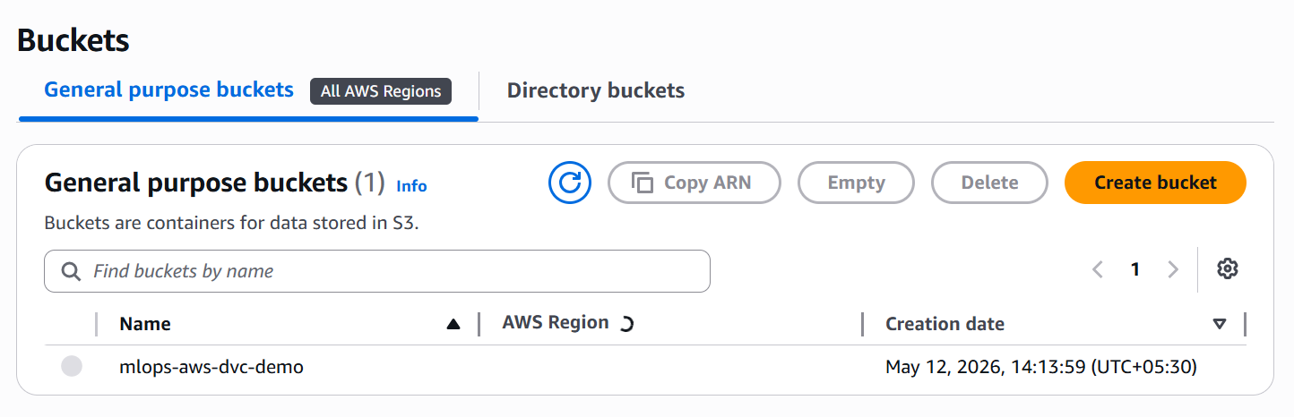

Where Remote Info Is Stored
Inside:
.dvc/config
This file should also be committed to Git.

Step 11 — Configure AWS CLI Credentials
Run:
aws configure
Provide:
- AWS Access Key
- Secret Access Key
- Region

Important Security Note
Never store AWS credentials:
- Inside Git
- Inside source code
Only configure locally via CLI.

Step 12 — Push Dataset to S3
dvc push

What Happens?
DVC uploads:
- Actual dataset
- Into S3 bucket

S3 Bucket Structure
Example:
bucketname/folder/md5/checksum-file
DVC stores datasets internally using checksum-based structure.

Step 13 — Commit Metadata to Git
Commit:
- .dvc metadata files
- .dvc/config
Example:
git add data/wine_sample.csv.dvc
git add .dvc/config
git commit -m "Track dataset version"
git branch -M main
git remote add origin https://github.com/parameshnaathi/ML-Ops.git
git push -u origin main

Important Understanding
Git Stores
- Dataset metadata
- Remote configuration
S3 Stores
- Actual dataset files

Step 14 — Team Collaboration Workflow
Another developer clones repo and runs:
dvc pull

What Happens?
DVC:
- Reads .dvc metadata
- Finds remote S3 bucket
- Downloads exact dataset version

Why This Is Important
All team members get:
The exact same dataset version
This ensures:
- Reproducibility
- Consistent experiments
- Team synchronization

How Dataset Versioning Works
Suppose:
- Version 1 → 10 rows
- Version 2 → 11 rows
- Version 3 → duplicate removed
Each version generates:
- New checksum
- New .dvc metadata
DVC stores all versions safely in S3.

Key Idea About Source of Truth
Even if S3 contains:
- 10
- 50
- 100 dataset versions
The Git repository tells everyone:
Which dataset version should currently be used
because latest .dvc metadata is stored in Git.

Complete DVC Workflow
Dataset Changes
↓
dvc add
↓
Generate .dvc Metadata File
↓
Commit Metadata to Git
↓
dvc push
↓
Actual Dataset Stored in S3
↓
Team Members Run dvc pull
↓
Same Dataset Downloaded Everywhere

Important Files in Git Repository
Must Commit to Git
File/Folder | Purpose
.dvc/ | DVC configuration
.dvc/config | Remote storage info
*.dvc files | Dataset metadata/checksums
Source code | ML training code

Do NOT Store in Git
Item | Reason
Large datasets | Repository becomes huge
AWS credentials | Security risk

Final Big Picture
Component | Responsibility
Git | Version control for code + metadata
DVC | Dataset version management
AWS S3 | Actual dataset storage
.dvc files | Link Git → Dataset version

One-Line Understanding
DVC helps ML teams version large datasets efficiently while Git tracks only lightweight metadata and S3 stores the actual data.

- Experiment Tracking and MLFlow
  - What is Experiment Tracking?
Experiment Tracking means:
Recording everything related to ML model training runs
so that you can:
- Compare experiments
- Reproduce results
- Find the best model
- Understand what worked and what failed

Why Experiment Tracking Is Needed
In Machine Learning, models are rarely trained only once.
Data Scientists usually try many variations.

Common Things That Change Between Runs
Experiment Change | Example
Algorithm | Decision Tree vs Random Forest
Hyperparameters | Learning rate, epochs
Dataset | Old data vs new data
Preprocessing | Scaling, encoding

Problem Without Experiment Tracking
After multiple training runs:
You may forget:
- Which model performed best
- Which parameters were used
- Why accuracy improved
- Which dataset produced good results

Experiment Tracking Solves This Problem
It keeps a history of all ML experiments.

What Gets Tracked?
A good experiment tracking system stores:
Item | Example
Parameters | learning_rate=0.01
Metrics | accuracy=84%
Dataset Version | wine_data_v2.csv
Code Version | Git commit ID
Artifacts | model.pkl, graphs
System Info | Python version, GPU

Real-World Example (Wine Prediction)
Suppose you train multiple wine prediction models.

Run 1
Algorithm: Linear Regression
Learning Rate: 0.01
Accuracy: 78%

Run 2
Algorithm: Linear Regression
Learning Rate: 0.05
Accuracy: 84%

Run 3
Algorithm: Decision Tree
Accuracy: 81%

Why Tracking Helps
Without tracking:
You may forget why Run 2 performed best
With experiment tracking:
- Every run is recorded
- Results can be compared easily
- Best models are identified quickly

Common Experiment Tracking Tools
Tool | Purpose
MLflow | Experiment tracking & model registry
Weights & Biases | Visualization & tracking
DVC Experiments | Git-based experiment tracking
Neptune | ML metadata tracking

Typical Experiment Tracking Workflow
Train Model
↓
Log Parameters
↓
Log Metrics
↓
Save Model Artifacts
↓
Compare Runs
↓
Select Best Model

Simple Real-World Analogy
Experiment Tracking | Analogy
ML experiment logs | Scientist’s lab notebook
Metrics | Test results
Parameters | Experiment settings
Best run | Successful formula

Most Important Understanding
Experiment tracking helps you remember, compare, and reproduce ML training results.
Without it:
- ML work becomes messy
- Results become hard to reproduce
- Teams lose track of best models
With it:
- ML development becomes organized and reliable.

  - Introduction to MLflow
MLflow is an: Open-source MLOps framework for managing the ML lifecycle
It helps teams:
- Track experiments
- Manage models
- Reproduce results
- Organize ML workflows

Simple Understanding of MLflow
MLflow helps answer:
Which model was trained,
with what parameters,
and how good was it?

Why MLflow Is Needed
In real ML projects, many problems appear.

Common Problems Without MLflow
Problem | Example
Too many experiments | Different model runs
No tracking | Forgetting best parameters
Difficult reproducibility | Cannot recreate results
Models stored locally | No version control
Deployment confusion | Unsure which model to use

What MLflow Solves
MLflow acts as a:
Central system for managing ML experiments and models

Core Components of MLflow
MLflow has 4 major components.

MLflow Tracking
Purpose
Used for:
Experiment Tracking

What Can Be Logged?
Item | Example
Parameters | learning_rate=0.01
Metrics | accuracy=92%
Artifacts | model.pkl, graphs
Code Version | Git commit

Important Concept
Every training execution is stored as a:
Run

Example
import mlflow

with mlflow.start_run():
mlflow.log_param("learning_rate", 0.01)
mlflow.log_metric("accuracy", 0.92)

Viewing Experiments
Run:
mlflow ui
This opens a dashboard where you can:
- Compare runs
- View metrics
- Select best models

MLflow Models
Purpose
MLflow Models provide a:
Standard way to package ML models

Why This Is Useful
The same model can be:
- Loaded in Python
- Served via API
- Dockerized
- Deployed to Kubernetes/cloud

Important Benefit
Models become portable and production-ready

MLflow Projects
Purpose
Package ML code with:
- Dependencies
- Environment details
- Execution commands

Why It Helps
Makes ML workflows:
- Reproducible
- Shareable
- Easier for teams

MLflow Model Registry
Purpose
Central place to manage models.

What It Stores
Feature | Purpose
Model Versions | Track model changes
Stages | Staging / Production
Metadata | Model information
Approvals | Enterprise workflows

Real-World Example (Wine Prediction)
Suppose you train multiple models.

Run 1
learning_rate = 0.01
accuracy = 86%

Run 2
learning_rate = 0.1
accuracy = 89%

Run 3
learning_rate = 0.001
accuracy = 82%

Without MLflow
Problems:
- Forgetting results
- Overwriting models
- Guessing best model

With MLflow
Benefits:
- Every run is stored
- Metrics are compared visually
- Best model is identified easily
- Models are versioned properly

How MLflow Fits into MLOps
MLflow supports:
- Experiment tracking
- Reproducibility
- Model management
- Deployment preparation

MLflow in Real MLOps Projects
MLflow is commonly used with:
Tool | Purpose
Git | Code versioning
DVC | Data versioning
GitHub Actions | CI/CD
Docker | Containerization
Kubernetes | Deployment
AWS S3 | Artifact storage

Typical MLflow Workflow
Train Model
↓
Log Parameters & Metrics
↓
Store Model Artifacts
↓
Compare Experiments
↓
Register Best Model
↓
Deploy Model

Simple Real-World Analogy
MLflow Component | Analogy
Tracking | Scientist’s experiment notebook
Models | Packaged final product
Registry | Warehouse of approved models
Projects | Standardized recipe

Most Important Understanding
MLflow helps teams organize, track, compare, and manage ML experiments and models efficiently.
It brings:
- Structure
- Reproducibility
- Collaboration
- Production readiness
to Machine Learning workflows.

  - MLflow Basic Installation & Setup
Create Project Folder
mkdir mlflow-basic-install
cd mlflow-basic-install

Create Virtual Environment
python3 -m venv .venv

Activate Virtual Environment
Linux/macOS
source .venv/bin/activate
Windows Git Bash
source .venv/Scripts/activate

Install MLflow
Recommended
pip install mlflow

Important Issue Faced
If you install using:
python3 -m pip install mlflow
you may get:
mlflow: command not found
Reason
MLflow installed outside .venv or executable not available in PATH.
Fix
Install inside activated .venv:
pip install mlflow

Verify Installation
mlflow --version

Start MLflow UI
mlflow ui --backend-store-uri sqlite:///mlflow.db --port 7006

What This Command Does
Command Part | Purpose
mlflow ui | Starts MLflow UI
sqlite:///mlflow.db | Stores experiments in SQLite DB
--port 7006 | Runs UI on port 7006

What Gets Created
mlflow.db
Stores:
- Experiments
- Runs
- Parameters
- Metrics
- Tags

Open in Browser
http://localhost:7006

Complete Flow
Create Folder
↓
Create .venv
↓
Activate .venv
↓
Install MLflow
↓
Verify Installation
↓
Start MLflow UI
↓
Open Browser
Real UI:
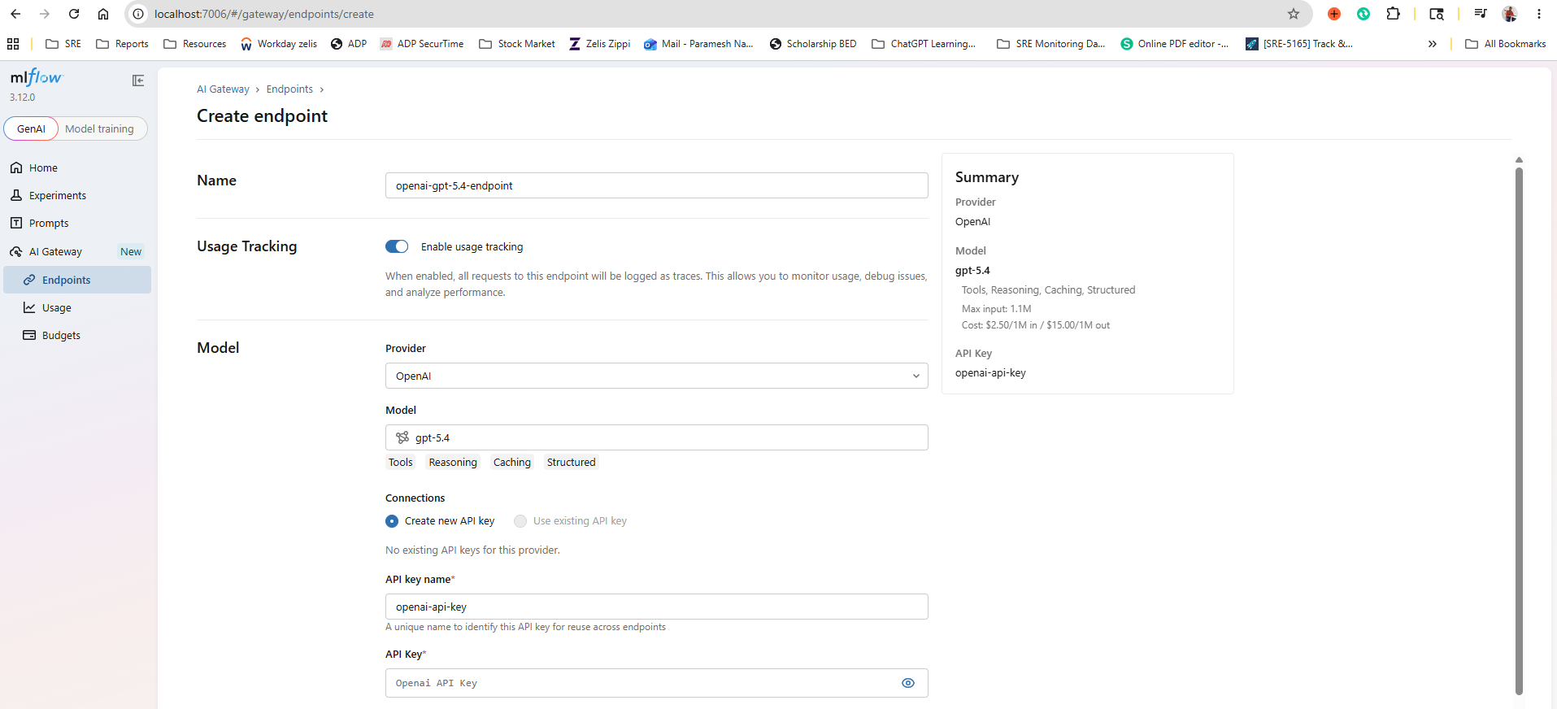
  - Basic MLFlow installation on Kubernetes [Non Production, Demo Purpose]
Basic MLflow Installation on Kubernetes (Demo / Non-Production Setup)
Overview
This guide explains how to install and run MLflow on Kubernetes locally using:
- Kind (Kubernetes in Docker)
- Helm
- Kubernetes
This setup is intended only for:
- Learning
- Practice
- Demo purposes
It is NOT recommended for production environments.

Architecture Overview
Docker
↓
Kind Cluster
↓
Helm Deployment
↓
MLflow Pod
↓
Port Forwarding
↓
Access MLflow UI in Browser

Prerequisites
Ensure the following tools are installed:
Tool | Purpose
Docker Desktop | Container runtime
Kind | Local Kubernetes cluster
kubectl | Kubernetes CLI
Helm | Kubernetes package manager
Chocolatey (Optional) | Windows package manager

Step 1 — Create Kind Kubernetes Cluster
Run:
kind create cluster --name basic-mlflow-cluster
What It Does
Creates a local Kubernetes cluster named:
basic-mlflow-cluster

If kind Is Not Installed
Install using Chocolatey:
choco install kind

If choco Is Not Installed
Install Chocolatey first from:
https://chocolatey.org/install
Then install Kind again.

Step 2 — Verify Cluster Creation
Run: kubectl cluster-info

Step 3 — Update Helm Repositories
Run: helm repo update
What It Does
Fetches the latest Helm chart metadata.

If helm Is Not Installed
Install using Chocolatey:
choco install kubernetes-helm

Step 4 — Install MLflow Using Helm
Run: helm install mlflow-community community-charts/mlflow
What It Does
Deploys MLflow into the Kubernetes cluster.

Official Documentation Reference
Refer: https://community-charts.github.io/docs/charts/mlflow/basic-installation

Step 5 — Verify MLflow Pod
Run: kubectl get pods
Expected Output
You should see a pod similar to:
mlflow-community-xxxx
Status should become: Running

Step 6 — Port Forward MLflow Service
Run: kubectl port-forward pod/mlflow-community-xxxx 7006:5000 --address 0.0.0.0

What This Command Does
Part | Purpose
7006 | Local machine port
5000 | MLflow container port
port-forward | Exposes pod locally
0.0.0.0 | Allows external/local access

Step 7 — Access MLflow UI
Open browser:
http://localhost:7006
You should now see the MLflow UI running on Kubernetes.


Complete Workflow
Install Docker
↓
Install Kind
↓
Create Kubernetes Cluster
↓
Install Helm
↓
Deploy MLflow Helm Chart
↓
Verify Pods
↓
Port Forward MLflow Pod
↓
Access MLflow UI

  - Production MLflow Setup on Kubernetes with PostgreSQL
(Local Demo Setup – Easy Reference Guide)

Required Tools
Tool | Purpose
Docker Desktop | Required for Kind Kubernetes cluster
Kind | Creates local Kubernetes cluster
kubectl | Kubernetes command-line tool
Helm | Deploys MLflow Helm charts
PostgreSQL | Backend database for MLflow
Chocolatey (Optional) | Windows package manager

Architecture Overview
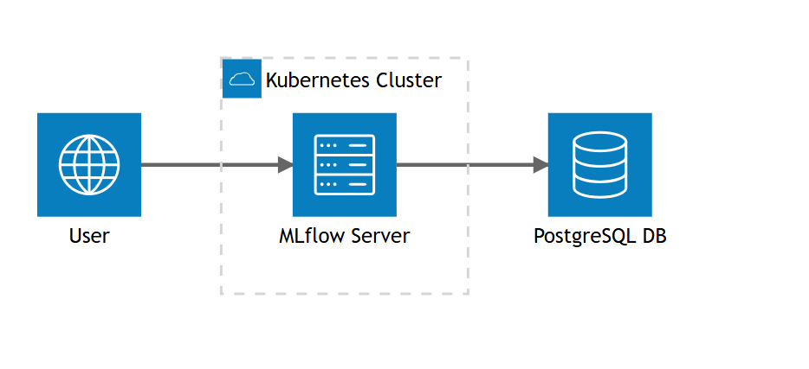
The setup architecture looks like this:
User
↓
MLflow Server (Running inside Kubernetes Cluster)
↓
PostgreSQL Database
Components
Component | Purpose
User | Accesses MLflow UI
MLflow Server | Tracks experiments/models
Kubernetes Cluster | Runs MLflow containers
PostgreSQL DB | Stores experiment metadata

Step 1 — Install PostgreSQL Locally
Install PostgreSQL using Chocolatey
choco install postgresql

If choco Is Not Installed
Install Chocolatey first:
https://chocolatey.org/install

Verify PostgreSQL Installation
Test Using Full Path
Run:
& "C:\Program Files\PostgreSQL\18\bin\postgres.exe" --version
& "C:\Program Files\PostgreSQL\18\bin\psql.exe" -V

If Commands Work
That means:
PostgreSQL is installed correctly

Add PostgreSQL to PATH (Temporary Current Session)
Run:
$env:Path += ";C:\Program Files\PostgreSQL\18\bin"

Verify Again
postgres --version
psql -V

Connect to Local PostgreSQL
Run:
psql -h localhost -p 5432 -U postgres -d postgres

Enter PostgreSQL Password
Example:
Password for user postgres:

Successful Login Output
postgres=#

Useful PostgreSQL Commands
Command | Purpose
\\l | List databases
\\du | List users
\\dt | List tables
\\q | Quit psql

Step 2 — Prepare MLflow Database
Run inside PostgreSQL:
CREATE DATABASE mlflow;
CREATE USER mlflow_user WITH PASSWORD 'postgres';
GRANT ALL PRIVILEGES ON DATABASE mlflow TO mlflow_user;

Step 3 — Create Kubernetes Cluster
Create Kind Cluster
kind create cluster --name production-mlflow-setup

Create Namespace
kubectl create namespace mlflow

Step 4 — Install MLflow Using Helm
Run: Windows
helm install mlflow community-charts/mlflow --namespace mlflow --set backendStore.databaseMigration=true --set backendStore.postgres.enabled=true --set backendStore.postgres.host=localhost --set backendStore.postgres.port=5432 --set backendStore.postgres.database=mlflow --set backendStore.postgres.user=mlflow_user --set backendStore.postgres.password=postgres
Run: For Mac
helm install mlflow community-charts/mlflow \
--namespace mlflow \
--set backendStore.databaseMigration=true \
--set backendStore.postgres.enabled=true \
--set backendStore.postgres.host=localhost \
--set backendStore.postgres.port=5432 \
--set backendStore.postgres.database=mlflow \
--set backendStore.postgres.user=mlflow_user \
--set backendStore.postgres.password=postgres

Expected Output
You should see:
STATUS: deployed
REVISION: 1

What This Command Does
Configuration | Purpose
backendStore.databaseMigration=true | Creates required DB tables
postgres.enabled=true | Enables PostgreSQL backend
host=localhost | PostgreSQL host
database=mlflow | MLflow DB
user=mlflow_user | DB username
password=postgres | DB password

Step 5 — Verify MLflow Pods
Run:
kubectl get pods -n mlflow -w

Expected State
Pods should move to:
Running
This may take:
1–2 minutes

Common Errors & Fixes
ImagePullBackOff
Cause
Docker image cannot be downloaded.
Debug
kubectl describe pod <pod-name> -n mlflow
Possible Fixes
- Check internet connectivity
- Verify Docker image exists
- Verify image name/tag

CrashLoopBackOff
Cause
Container starts and crashes repeatedly.
Debug Logs
kubectl logs <pod-name> -n mlflow

Common Reasons
Reason | Fix
Wrong DB credentials | Verify PostgreSQL username/password
PostgreSQL unreachable | Ensure PostgreSQL running
Invalid Helm values | Recheck Helm command
Missing environment variables | Verify configuration

Restart Deployment
kubectl rollout restart deployment mlflow -n mlflow

Delete Failed Pod
kubectl delete pod <pod-name> -n mlflow
Kubernetes will recreate it automatically.

Step 6 — Port Forward MLflow
Run:
kubectl port-forward pod/mlflow-66c784fcfd-7zm2w \
-n mlflow \
7004:5000 \
--address 0.0.0.0

What This Command Does
Port | Purpose
7004 | Local machine port
5000 | MLflow container port

Step 7 — Access MLflow UI
Open browser:
http://localhost:7004

Expected Result
You should now see:
MLflow Production UI running on Kubernetes
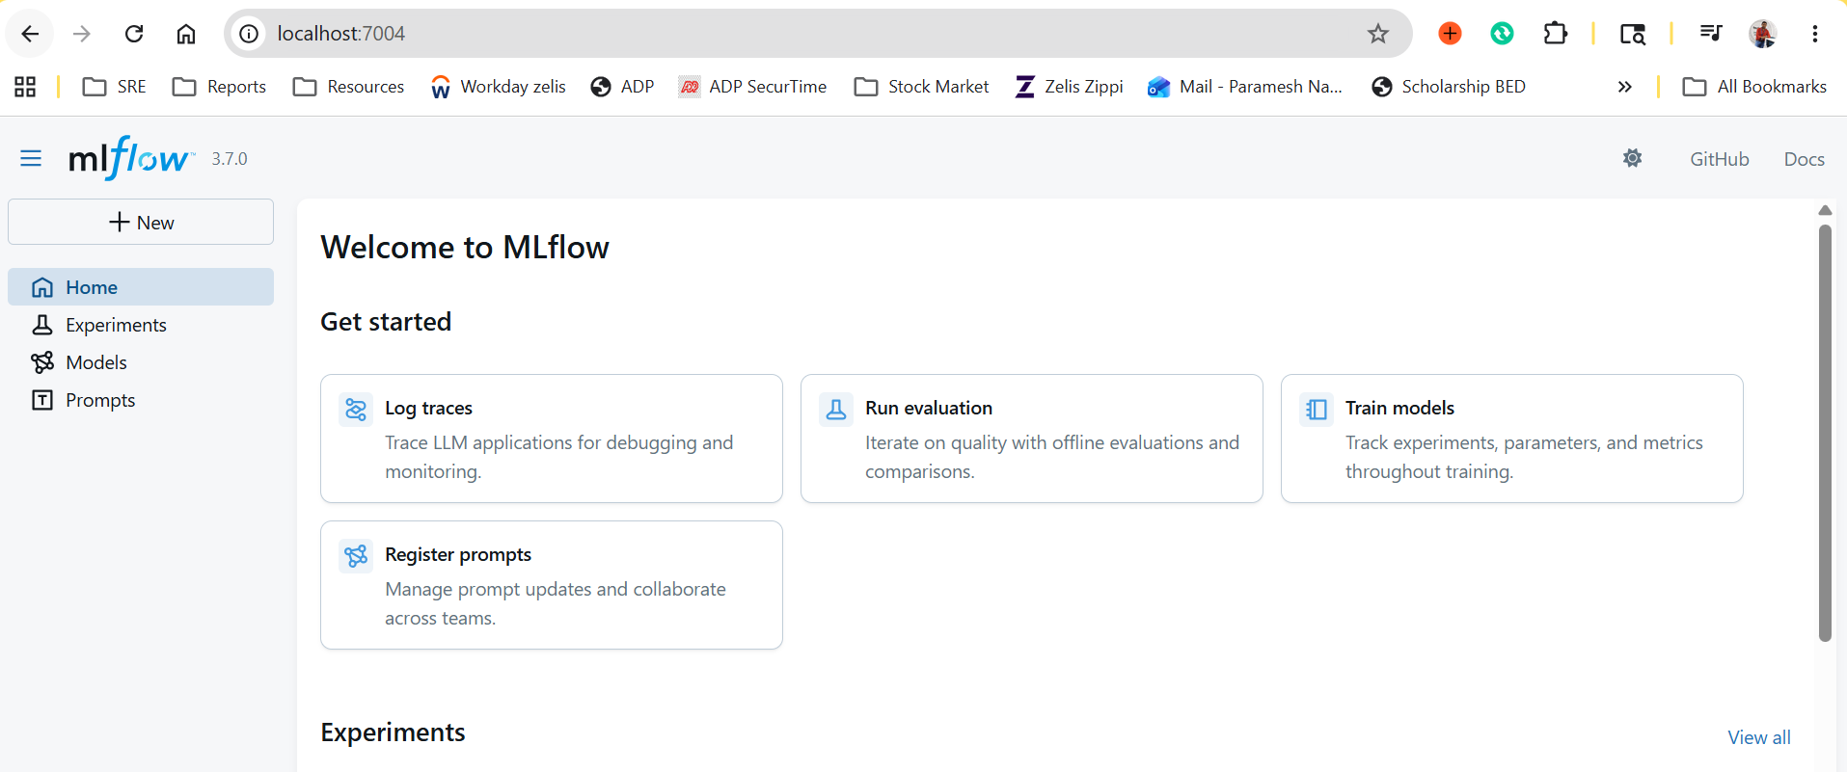

Complete End-to-End Workflow
Install PostgreSQL
↓
Create MLflow Database
↓
Create Kind Kubernetes Cluster
↓
Create Namespace
↓
Install MLflow using Helm
↓
Verify Pods
↓
Fix Any Pod Errors
↓
Port Forward MLflow Service
↓
Access MLflow UI

Important Notes
This Setup Is Good For
- Learning Kubernetes
- Learning MLflow
- Demo environments
- Local MLOps practice

This Setup Is NOT Production-Ready
Real production setups usually use:
- AWS RDS / Aurora PostgreSQL
- Ingress Controller
- HTTPS/TLS
- Persistent Volumes
- S3 Artifact Storage
- Monitoring & Logging
- Authentication
- Autoscaling

One-Line Summary
Kubernetes runs MLflow, PostgreSQL stores experiment metadata, and Helm automates deployment.

  - Realtime Experiment Tracking with MLflow for Wine Prediction Model[DVC + MLflow Integration]

Goal of This Demo
This demo explains how to:
- Connect local ML training with MLflow
- Track experiments in real-time
- Pull datasets using DVC
- Train Wine Prediction model
- Push metrics/models into MLflow UI
This is one of the most important practical MLOps workflows.

DVC + MLflow Architecture
Git Repository
↓
DVC Pull
↓
Dataset Download
↓
Train.py
↓
MLflow Tracking
↓
MLflow UI

Part 1 — Setup MLflow Connection

Step 1 — Create Project Folder
mkdir mlflow-connect
cd mlflow-connect
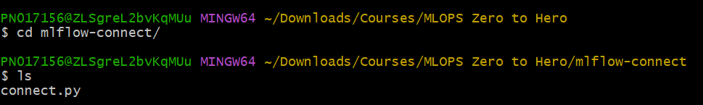

Step 2 — Create Virtual Environment
python3 -m venv .venv

Step 3 — Activate Virtual Environment
Windows Git Bash
source .venv/Scripts/activate

Step 4 — Install MLflow
pip install mlflow

Step 5 — Create connect.py
Create:
connect.py

Add Below Code
import mlflow

mlflow.set_tracking_uri("http://localhost:7004/")
mlflow.set_experiment("myfirst_experiment_demo")

What This Code Does
Code | Purpose
set_tracking_uri() | Connects to MLflow server
set_experiment() | Creates/selects experiment

Step 6 — Run Script
python connect.py

Expected Result
MLflow automatically creates:
myfirst_experiment_demo
inside MLflow UI.
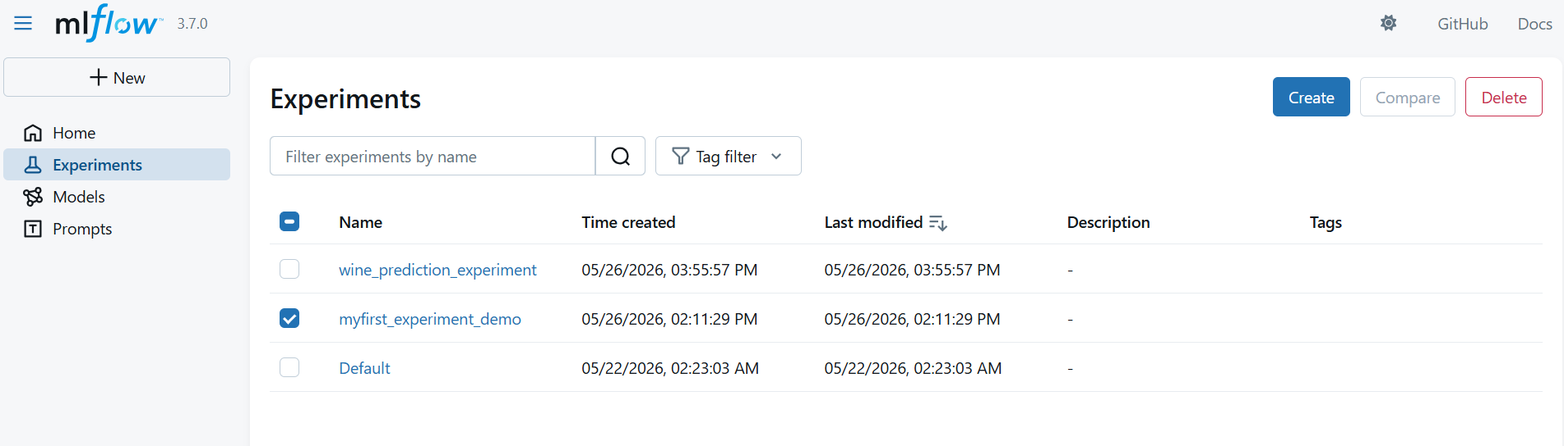

Part 2 — Clone Wine Prediction Project

Step 7 — Clone Repository
Use any one repo:
git clone https://github.com/iam-veeramalla/Wine-Prediction-Model.git
OR
git clone https://github.com/parameshnaathi/wine_prediction_model.git

Step 8 — Move Into Repository
cd wine_prediction_model

Step 9 — Initialize Git
git init

Step 10 — Add Remote Repository
git remote add origin https://github.com/parameshnaathi/wine_prediction_model.git

Step 11 — Create Virtual Environment
python3 -m venv .venv

Step 12 — Activate Virtual Environment
source .venv/Scripts/activate

Part 3 — Pull Dataset Using DVC

Important Understanding
Git stores metadata
DVC stores actual datasets/models

If AWS S3 Remote Was Deleted Earlier
Use:
- Recreate S3 bucket by referring 3.3. DVC Demo – Step-by-Step Structured Summary
OR
- Local DVC remote

Pull Latest Dataset
dvc pull

What This Does
Downloads:
- dataset
- model artifacts
- tracked files
from DVC remote storage.

Part 4 — Configure Experiment Tracking

Step 13 — Open train.py
Locate this line:
p.add_argument("--experiment", default="wine_prediction_experiment", help="MLflow experiment name")

Update Experiment Name If Needed
Example:
default="wine_prediction_demo"

Why This Matters
MLflow will create experiments using this name.
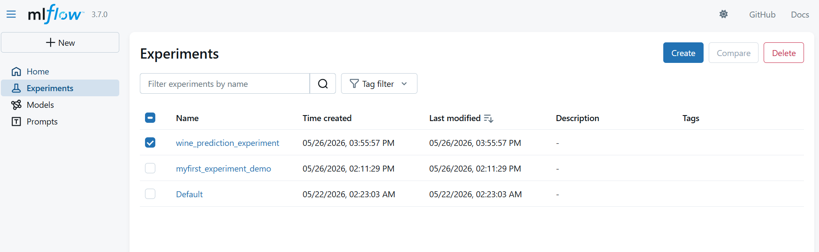

Part 5 — Install Project Dependencies

Step 14 — Install Requirements
pip install -r requirements.txt

Dependencies Installed
Package | Purpose
pandas | Data processing
scikit-learn | ML algorithms
joblib | Save models
numpy | Numerical operations
mlflow | Experiment tracking

Part 6 — Connect Training Script to MLflow

Step 15 — Set MLflow Tracking URI
Git Bash
export MLFLOW_TRACKING_URI=http://localhost:7004

PowerShell
$env:MLFLOW_TRACKING_URI="http://localhost:7004"

What This Does
Tells training script:
Send all experiment logs to MLflow server

Part 7 — Run Wine Prediction Training

Step 16 — Execute Training Script
python -u train.py

What Happens Internally
Dataset Loaded
↓
Model Training Starts
↓
Metrics Calculated
↓
MLflow Logs Parameters
↓
MLflow Logs Metrics
↓
Model Artifacts Stored
↓
Experiment Appears in MLflow UI

Expected Result
MLflow creates:
wine_prediction_experiment
with:
- parameters
- metrics
- model artifacts
- run details

Screenshot Placeholder
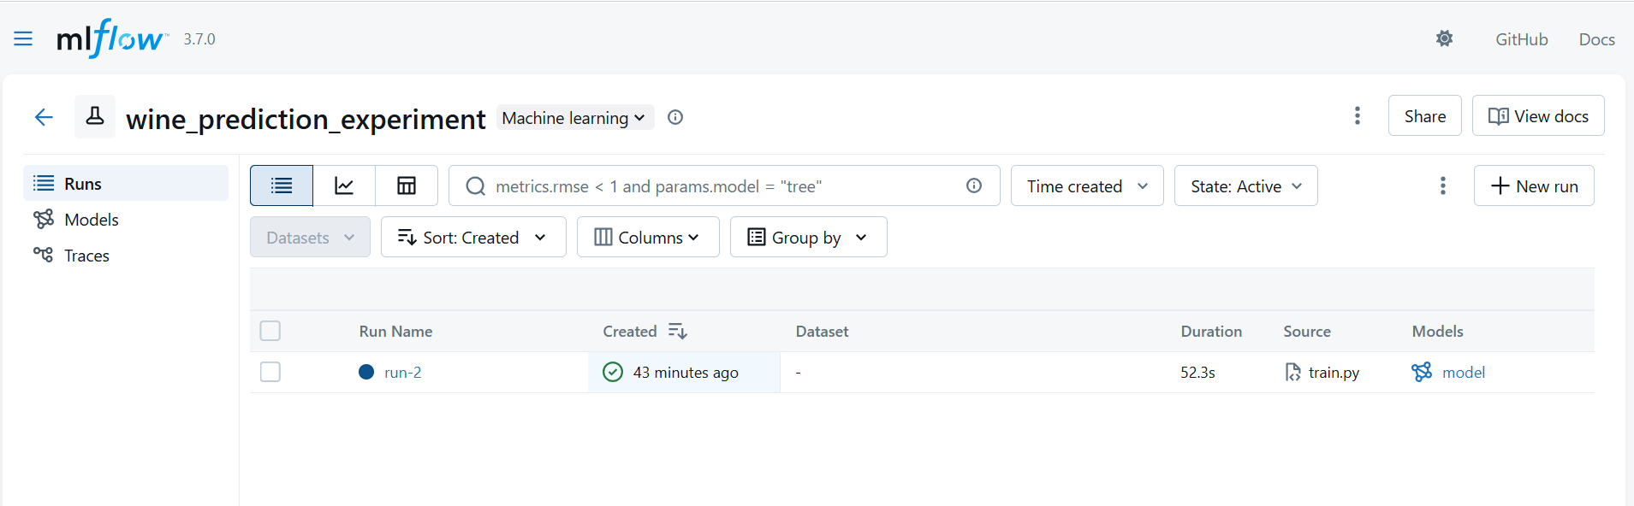
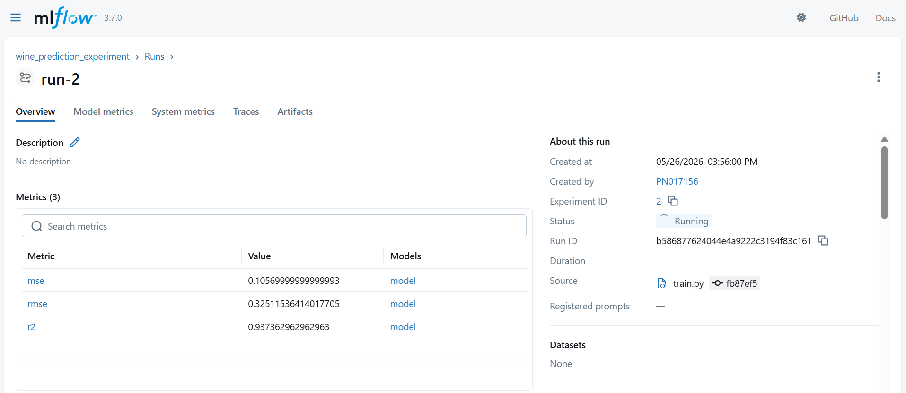
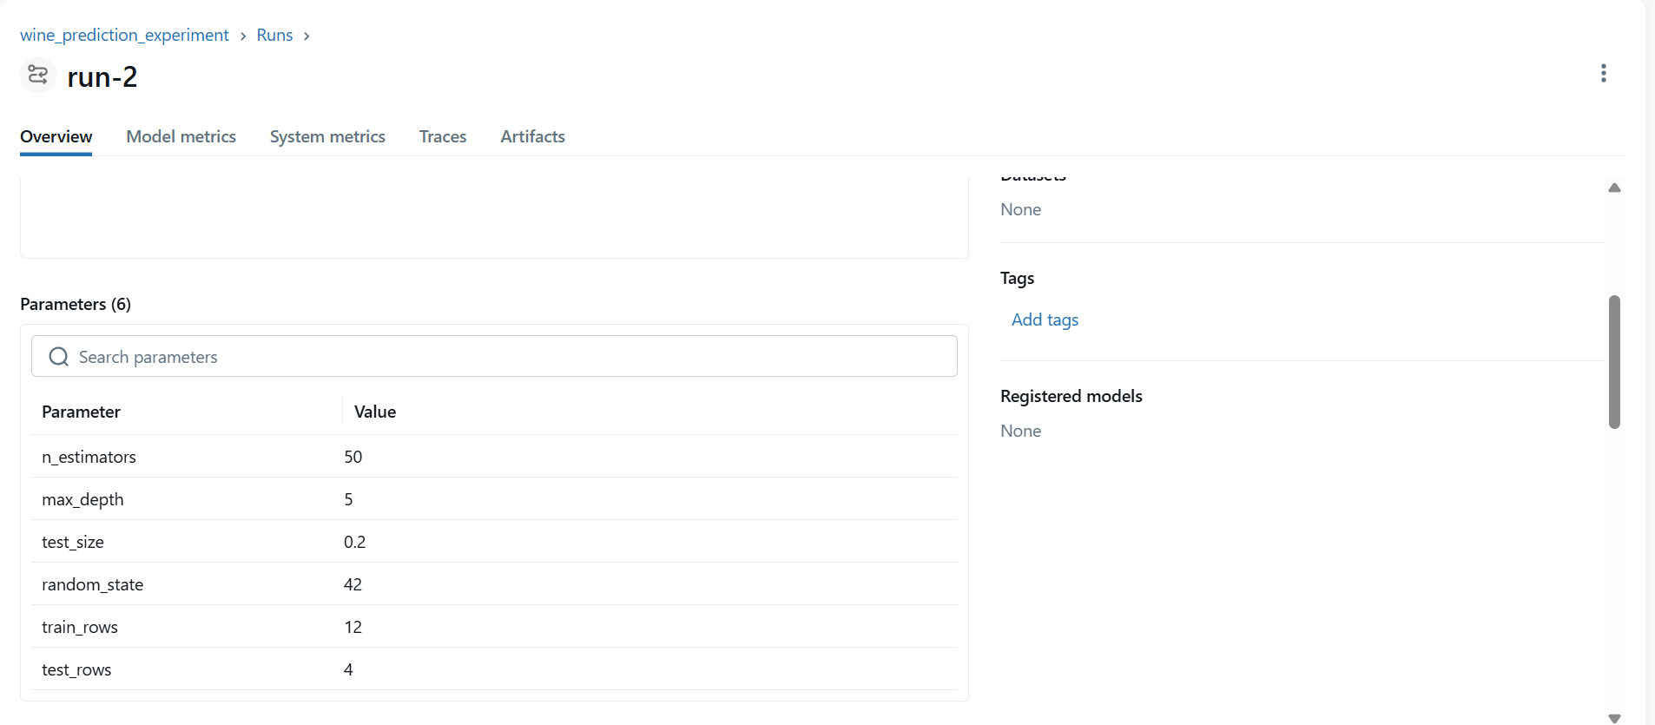
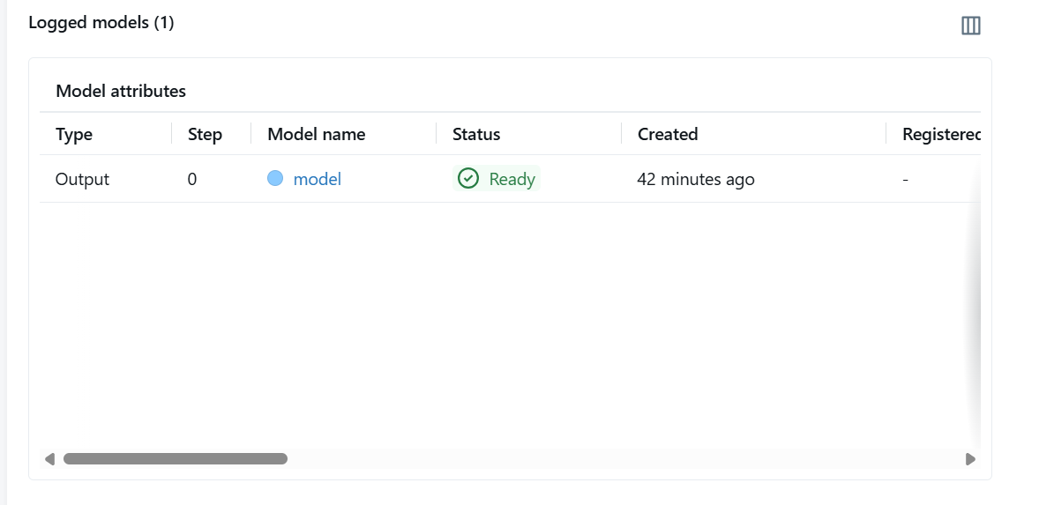

Real-Time Flow Architecture
Developer
↓
train.py
↓
MLflow Tracking URI
↓
MLflow Server on Kubernetes
↓
PostgreSQL Backend
↓
MLflow UI Dashboard

Important Concepts Learned
Concept | Understanding
DVC | Dataset versioning
MLflow | Experiment tracking
Tracking URI | MLflow server endpoint
Experiment | Group of training runs
Run | Single training execution
Metrics | Accuracy/loss values
Artifacts | Saved model files

End-to-End Workflow
Clone Repository
↓
Pull Dataset using DVC
↓
Install Dependencies
↓
Configure MLflow Tracking URI
↓
Run train.py
↓
MLflow Tracks Experiment
↓
View Results in MLflow UI

One-Line Summary
DVC manages datasets, MLflow tracks experiments, and train.py sends model metrics and artifacts to the MLflow server in real time.

  - Comparing multiple runs in an experiments visually using MLflow

Goal of This Demo
This demo explains how MLflow helps compare multiple experiment runs visually.
This is one of the most powerful features of MLflow because it helps teams decide:
Which model/configuration performs better?

Why Multiple Runs Are Important
In real ML projects, Data Scientists try many experiments by changing:
- Hyperparameters
- Dataset size
- Algorithms
- Features
- Train/Test split
Every change creates a new MLflow run.

Example in This Demo
Initially:
test_size = 0.2
Now change it to:
test_size = 0.9

What This Means
test_size | Meaning
0.2 | 20% testing data
0.9 | 90% testing data
This change affects:
- model training quality
- dataset distribution
- evaluation metrics

Step 1 — Modify train.py
Locate:
test_size=0.2
Change to:
test_size=0.9
Save the file.

Step 2 — Set MLflow Tracking URI
Git Bash
export MLFLOW_TRACKING_URI=http://localhost:7004

Step 3 — Run Training Again
python train.py

What Happens Internally
Modified train.py
↓
New MLflow Run Created
↓
Parameters Logged
↓
Metrics Logged
↓
Artifacts Logged
↓
Run Appears in MLflow UI

Expected Result
MLflow now contains:
- run-1
- run-2
- run-3
(or similar runs)
Each run has:
- different parameters
- different metrics
- different performance

Screenshot Placeholder
Select all the runs or required runs -> Click on compare
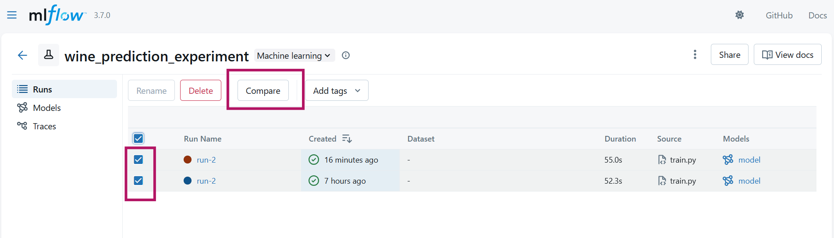
We will see different kind of plots
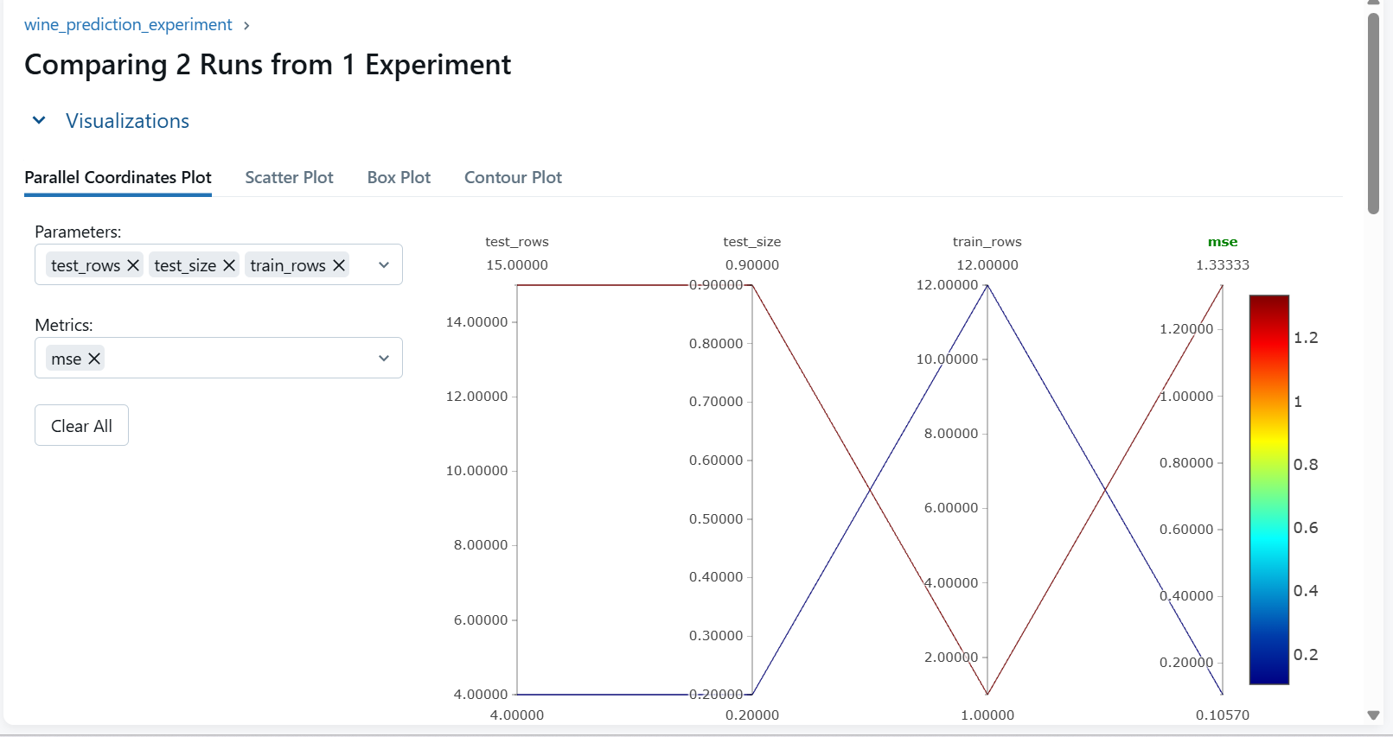
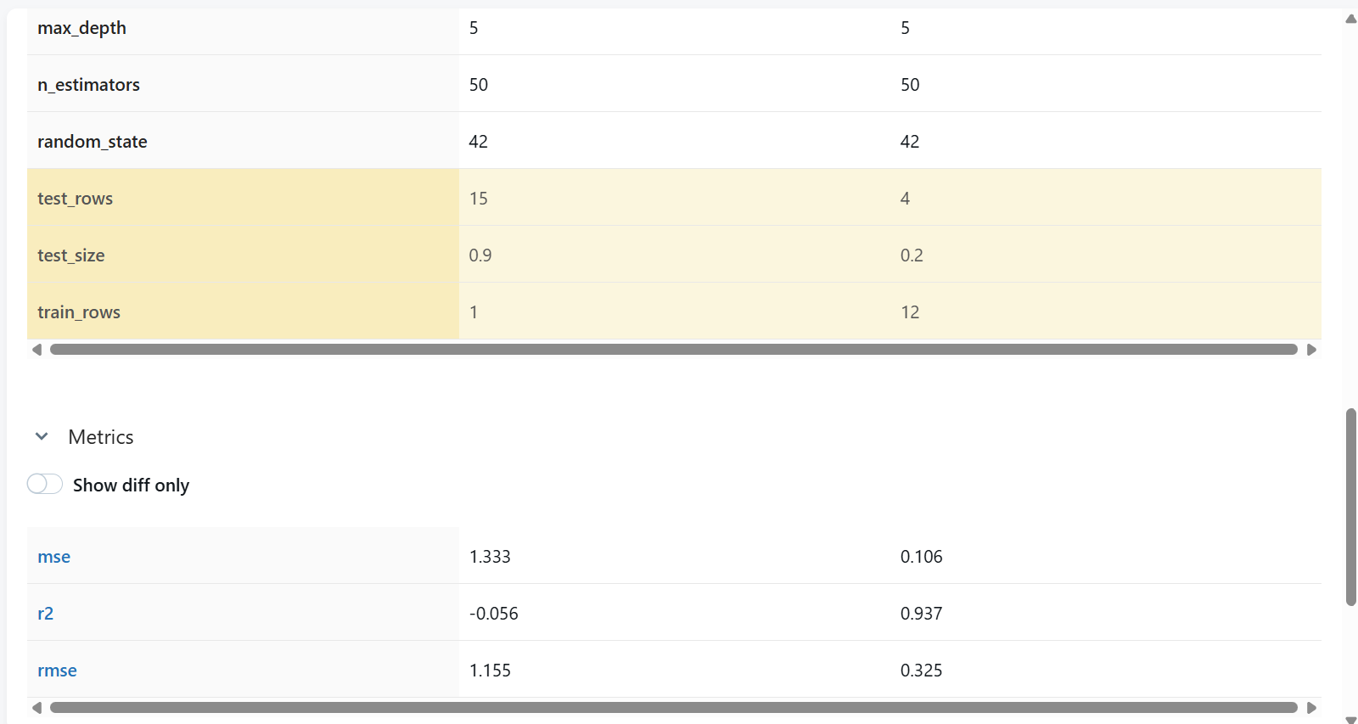
From this we can decide run-2 is better than run-1

Comparing Runs in MLflow
MLflow allows visual comparison of:
Comparison Type | Example
Metrics | RMSE, Accuracy
Parameters | test_size, max_depth
Runtime | Training duration
Models | Different model outputs

Example Comparison
Run | test_size | RMSE | R² Score
run-1 | 0.2 | 0.32 | 0.93
run-2 | 0.9 | 0.85 | 0.42

Observation
run-1 performs much better than run-2
because:
- lower RMSE
- higher R² score

Why This Feature Is Important
Without MLflow:
- difficult to remember results
- hard to compare experiments
- confusion about best model
With MLflow:
- all runs are tracked centrally
- comparisons become visual and easy

What Teams Usually Do
After comparison:
Select the best-performing run
Example:
run-2

How Production Teams Use This
Data Scientists and ML Engineers:
- Open best run
- Go to Overview section
- Check Source section
- Copy Git Commit ID

Why Commit ID Matters
The commit ID identifies:
Exact code version that produced the best model

Example Commit ID
d3cee8ed009cf870c8974877d7e179cfed8e3bb5

What Happens Next
Teams use this commit ID to:
Pull exact training code
↓
Build Docker image
↓
Deploy best model to production

Screenshot Placeholder
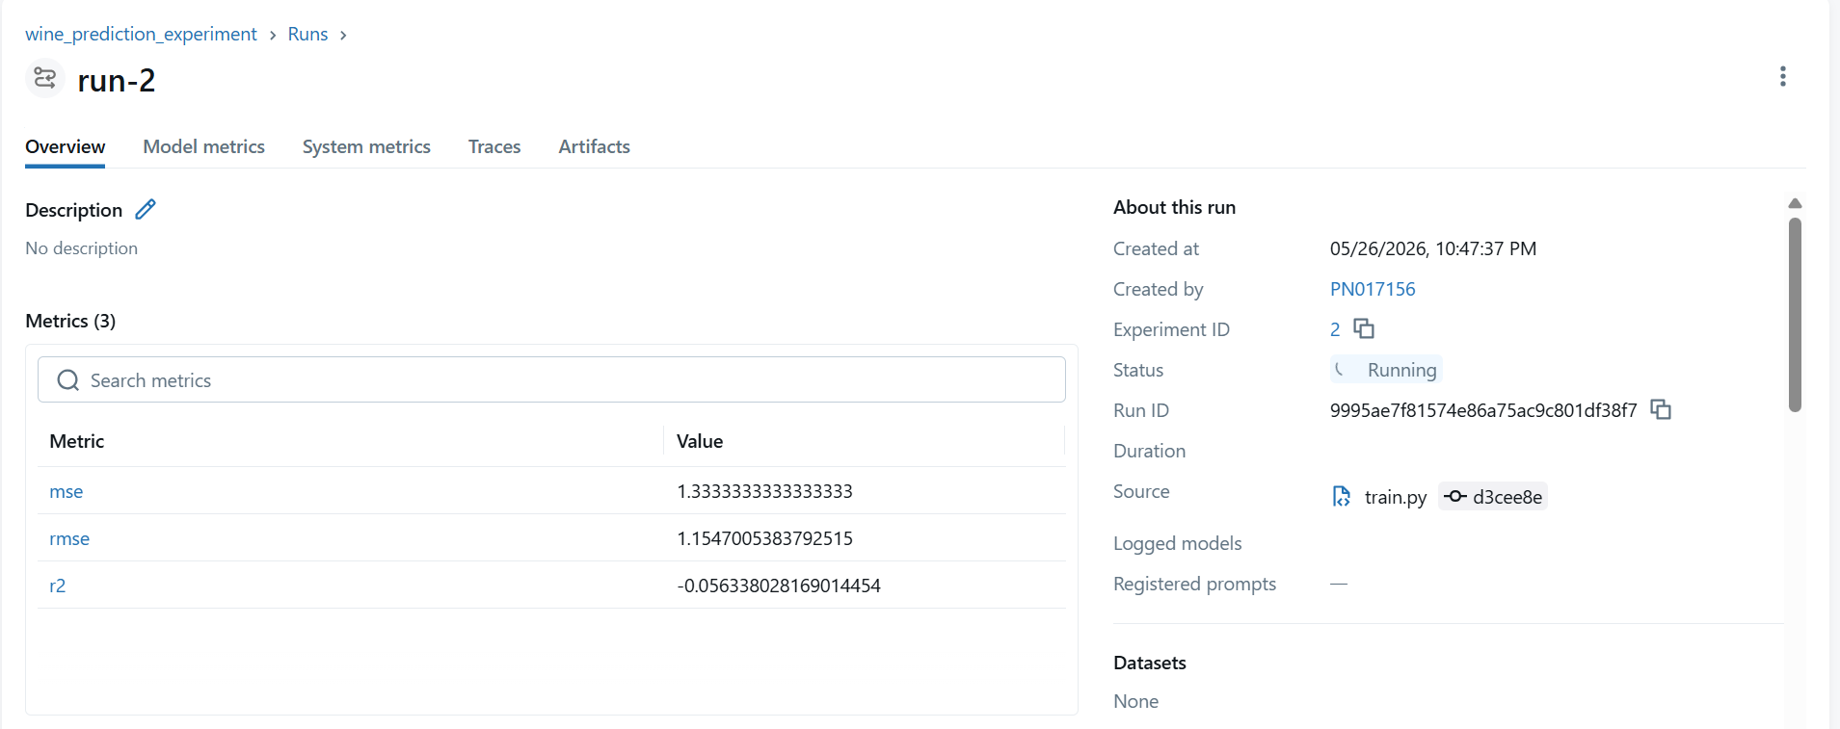
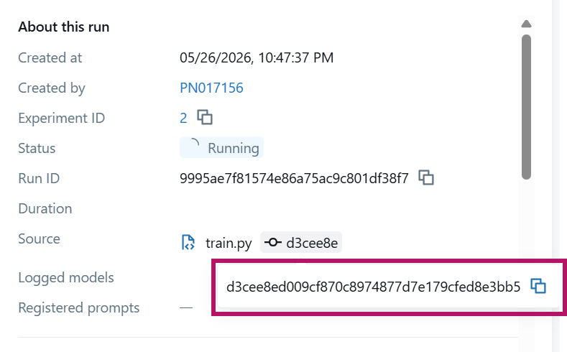

Real-World MLOps Workflow
Experiment Multiple Runs
↓
Compare Metrics in MLflow
↓
Select Best Run
↓
Identify Commit ID
↓
Use Exact Code Version
↓
Deploy to Production

Why This Is Extremely Powerful
MLflow provides:
Capability | Benefit
Experiment history | Never lose results
Visual comparison | Easier decision making
Commit tracking | Full reproducibility
Metrics comparison | Better model selection
Source tracking | Production confidence

Important Understanding
Production deployment should always use the exact code version that created the best-performing model.
MLflow helps achieve this using:
- run tracking
- metrics
- parameters
- Git commit linkage

Architecture Overview
train.py
↓
MLflow Tracking Server
↓
Experiment Runs Stored
↓
Visual Comparison in UI
↓
Best Run Selected
↓
Commit ID Used for Deployment

One-Line Summary
MLflow helps visually compare multiple experiment runs so teams can confidently choose and deploy the best-performing model version.

6.1. Introduction to Model Deployment and Model Serving
Machine Learning models become useful only when real users or systems can use them.
Training a model alone does not create business value.
The model must be:
- Deployed
- Served
- Accessible to applications

What Is Model Deployment?
Model Deployment means:
Moving a trained ML model into a production environment

Simple Understanding
Deployment involves:
- Taking the trained model from local machine
- Packaging required code & dependencies
- Making it accessible to users/systems

Who Uses Deployed Models?
A deployed model can be used by:
- Web applications
- Backend services
- Mobile apps
- Data pipelines
- Batch processing systems

What Is Model Serving?
Model Serving means:
Running the deployed model and serving predictions to users/applications

What Happens During Model Serving?
A serving system:
Loads Model
↓
Receives Input Request
↓
Runs Prediction (Inference)
↓
Returns Prediction Response

Example Prediction Request
Input
{
"alcohol": 11.5,
"volatile_acidity": 0.3
}

Output
{
"wine_quality": 8
}

Important Runtime Concepts
Model serving focuses on:
Concept | Meaning
Latency | Prediction response time
Throughput | Requests handled per second
Reliability | Stable predictions
Availability | Service uptime

Types of Model Serving

Real-Time Serving
Predictions are returned instantly.

Used For
- Fraud detection
- Recommendation systems
- Chatbots
- APIs

Characteristics
Feature | Description
Low latency | Fast response required
Online predictions | Real-time requests

Batch Serving
Predictions run on large datasets periodically.

Used For
- Nightly predictions
- Weekly reports
- Bulk scoring systems

Characteristics
Feature | Description
Scheduled execution | Runs at intervals
Large datasets | Offline processing

Why Deployment & Serving Matter
A model that is not deployed is:
Just an experiment

Production Systems Need
Requirement | Purpose
Scalability | Handle traffic growth
Fast responses | Better user experience
Monitoring | Detect failures
Logging | Debug issues
Rollbacks | Recover safely

Goal of Deployment & Serving
Make ML predictions reliable and usable in production

Common Deployment & Serving Methods

Python API-Based Serving
Simple APIs expose ML predictions.

Common Frameworks
Framework | Use Case
Flask | Simple APIs
FastAPI | High-performance APIs
Django | Full web applications

Best For
- Learning
- Small projects
- Simple deployments

Container-Based Deployment
Models are packaged into containers.

Common Tools
Tool | Purpose
Docker | Containerization
Kubernetes | Orchestration
Load Balancer | Traffic distribution

Benefits
- Scalability
- Portability
- Reliability

MLOps Model Serving Platforms
Specialized ML serving systems.

Common Platforms
Platform | Purpose
MLflow Serving | ML model deployment
KServe | Kubernetes serving
Seldon Core | Advanced ML serving
TensorFlow Serving | TensorFlow models
TorchServe | PyTorch models

Features Provided
Feature | Benefit
Auto-scaling | Handle traffic automatically
Versioning | Manage multiple models
Monitoring | Observe performance
Canary deployment | Safe rollout strategy

Serverless Deployment
Cloud providers run models without managing servers.

Examples
Platform | Provider
AWS Lambda | AWS
Cloud Run | GCP
Azure Functions | Azure

Best For
- Lightweight models
- Variable traffic
- Event-driven workloads

Simple End-to-End Serving Flow
Train Model
↓
Save Model File
↓
Load Model in API
↓
Expose /predict Endpoint
↓
Deploy API
↓
Users Send Requests
↓
Predictions Returned

Model Deployment vs Model Serving
Concept | Meaning
Model Deployment | Releasing model into production
Model Serving | Running model and handling predictions

Important Difference
Deployment
Usually:
- one-time activity
- version-based release
Example:
Deploying model v2

Serving
Continuous runtime operation.
Example:
Serving predictions 24/7

Real-World Analogy
ML Concept | Restaurant Analogy
Model Training | Cooking recipe creation
Deployment | Opening restaurant
Serving | Serving food to customers

Architecture Overview
Client Application
↓
Prediction API
↓
Model Serving System
↓
ML Model
↓
Prediction Response

Most Important Understanding
Deployment makes the model available.
Serving makes the model usable in real time.
Both are critical parts of production Machine Learning systems.

5.2. Popular Model Serving Implementations — High-Level Overview
This section explains four common ways to deploy and serve Machine Learning models in production.

1. Flask App on VM (WSGI + Autoscaling)
What It Is
A Python Flask API running on Virtual Machines (VMs).
The model is loaded inside the Flask app and exposed using REST APIs.
Usually served using:
- Gunicorn
- uWSGI (Web Server Gateway Interface)

Architecture
Client
↓
Load Balancer
↓
Flask API (VM)
↓
ML Model

Common Components
Component | Purpose
Flask | API framework
Gunicorn/uWSGI | Production server
VM | Runs application
Load Balancer | Distributes traffic

When to Use
✅ Small projects
✅ Learning/demo setups
✅ Low traffic systems
✅ Simple deployments

Pros
- Simple setup
- Easy debugging
- Quick prototyping

Cons
- Harder to scale
- VM management overhead
- Less portable than containers

Best Practices
- Use Gunicorn/uWSGI
- Load model once at startup
- Add health checks
- Monitor latency & logs

Key Understanding
Simple and beginner-friendly deployment approach

2. Containerized Deployment on Kubernetes
What It Is
Package model API into Docker containers and deploy on Kubernetes.
Traffic is managed using:
- Services
- Ingress
- Autoscaling

Architecture
Client
↓
Ingress / Load Balancer
↓
Kubernetes Pods
↓
Model API Container
↓
ML Model

Common Components
Component | Purpose
Docker | Containerization
Kubernetes | Orchestration
Ingress | Traffic routing
HPA | Autoscaling

When to Use
✅ Production systems
✅ High traffic applications
✅ Scalable deployments
✅ Enterprise MLOps

Pros
- Highly scalable
- Portable across environments
- Supports CI/CD & rolling updates

Cons
- More infrastructure complexity
- Requires Kubernetes knowledge

Best Practices
- Use readiness/liveness probes
- Keep images lightweight
- Use autoscaling
- Add monitoring & logging

Key Understanding
Most common production-grade deployment approach

3. Amazon SageMaker
What It Is
AWS-managed ML platform for:
- Training
- Deployment
- Model serving
- Monitoring
No need to manage servers manually.

Architecture
Client
↓
SageMaker Endpoint
↓
Hosted Model
↓
AWS Infrastructure

Common Features
Feature | Purpose
Hosted Endpoints | Real-time inference
Batch Transform | Batch predictions
Auto Scaling | Traffic scaling
Model Registry | Version management

When to Use
✅ AWS-based organizations
✅ Managed MLOps workflows
✅ Faster production deployment

Pros
- Fully managed
- Easy scaling
- Built-in monitoring
- AWS integrations

Cons
- AWS vendor lock-in
- Higher cost for heavy workloads

Best Practices
- Use autoscaling
- Enable Model Monitor
- Use Model Registry
- Optimize instance size

Key Understanding
Best for teams wanting managed MLOps on AWS

4. KServe (KFServing)
What It Is
KServe is a Kubernetes-native model serving platform.
It simplifies ML deployment using Kubernetes CRDs (Custom Resource Definitions).
Supports:
- TensorFlow
- PyTorch
- ONNX
- Triton
- Custom models

Architecture
Client
↓
Ingress / Istio
↓
KServe InferenceService
↓
Predictor Container
↓
ML Model

Common Features
Feature | Purpose
InferenceService | Standardized deployment
Autoscaling | Scale automatically
Canary rollout | Safe model updates
Scale-to-zero | Save cost

When to Use
✅ Advanced Kubernetes MLOps
✅ Multi-model serving
✅ Cloud-native ML platforms

Pros
- Kubernetes-native
- Advanced autoscaling
- Canary deployments
- Multi-framework support

Cons
- Higher Kubernetes complexity
- Requires KServe/Knative knowledge

Best Practices
- Use canary rollouts
- Store models externally (S3/GCS)
- Use monitoring tools
- Automate deployments with CI/CD

Key Understanding
Advanced cloud-native model serving framework on Kubernetes

Quick Comparison Table
Method | Best For | Complexity | Scalability
Flask on VM | Learning/small apps | Low | Medium
Kubernetes + Containers | Production systems | Medium-High | High
SageMaker | Managed AWS ML | Medium | High
KServe | Advanced K8s MLOps | High | Very High

Simplified Mental Model
Flask VM
↓
Simple API Deployment

Kubernetes
↓
Scalable Container Deployment

SageMaker
↓
Managed AWS Deployment

KServe
↓
Advanced Kubernetes-Native Serving

One-Line Summary
Different model serving approaches balance simplicity, scalability, operational effort, and production readiness.

